EAL focus – Tudor Primary 2017-2018- Evidencing our impact
Year 1
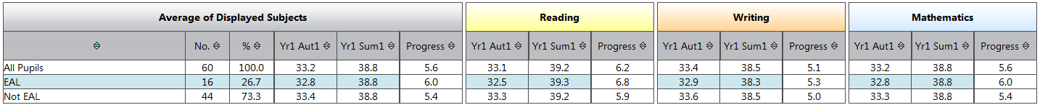
Year 2
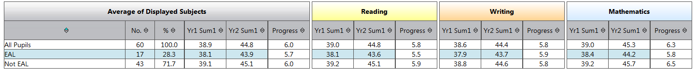
Year 3
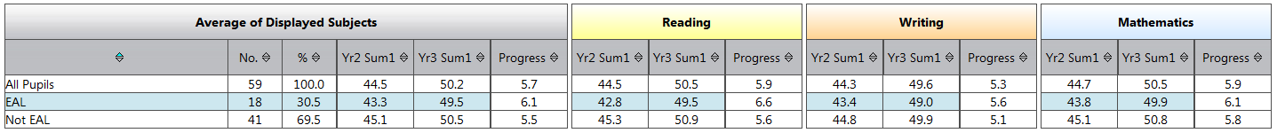
Year 4
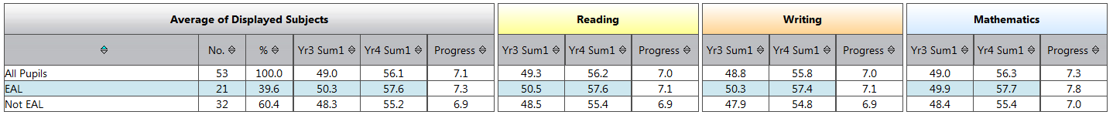
Year 5
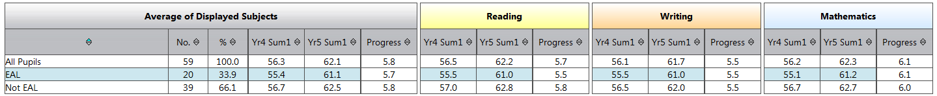
Year 6
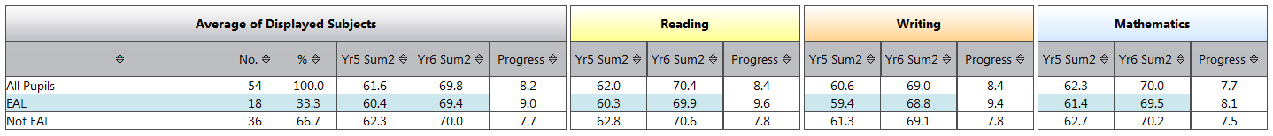
Progress for EAL is good in all years.
In the vast majority of classes/ subjects, EAL performs very well when compared with non EAL
(Following analysis = total of average progress/ 6 year groups)
Reading= EAL average progress = 6.9 (6.3 Not EAL)
Writing= EAL average progress = 6.5 (6.0 Not EAL)
Maths= EAL average progress= 6.7 (6.4 Not EAL)

