Pupil Premium Focus – Tudor Primary 2017-2018
Year 1
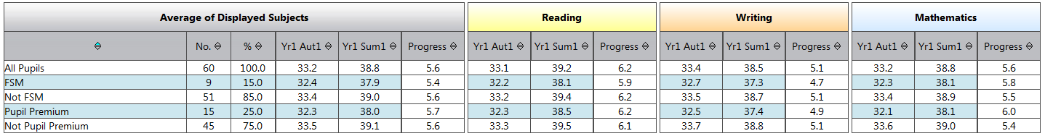
Year 2
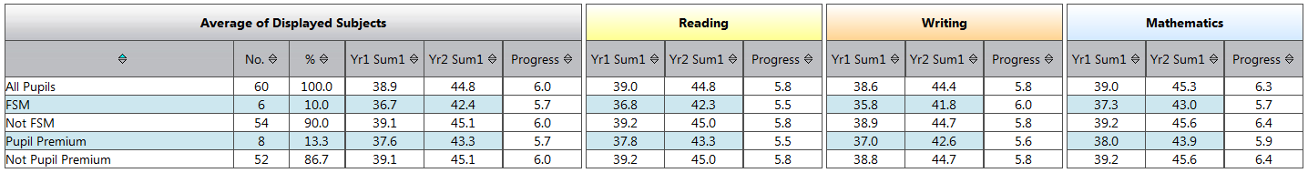
Year 3
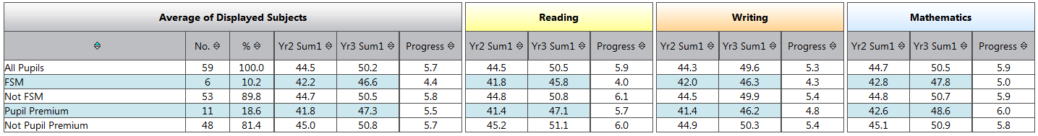
Year 4
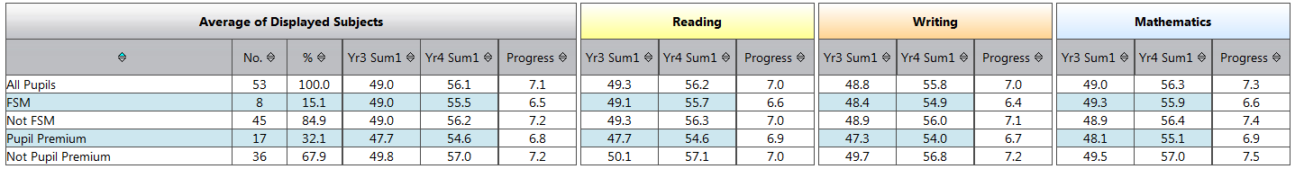
Year 5
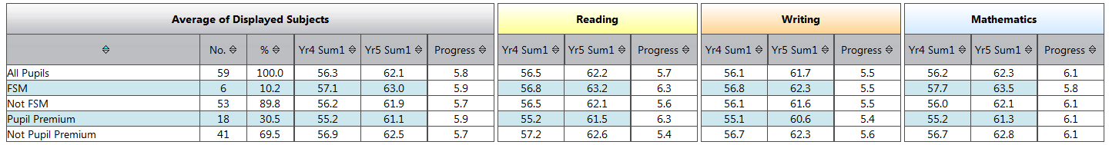
Year 6
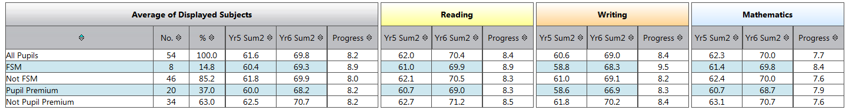
(Following analysis = total of average progress/ 6 year groups)
- On average:
Reading progress = 6.5 (FSM= 6.2)
Writing progress = 6 (FSM= 6.1)
Maths progress = 6.5 (FSM= 6.2)

