How to be a perfect pirate
Do you want to be a sneaky, sly pirate like Blackbeard? Do you want to have a name so terrorising that people faint when they say it? Well if that is you well, read on! If not just rip this up and throw it in bin. If you said yes to the question I asked earlier get ready for adventure!
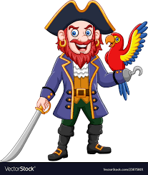
Ingredients
- 1 large, tough ship
- 1 sharp, pointy sword
- 12 painful, illegal guns
- 200 hostile, sinister crew members
- 1000,1000 cannon balls
- 20 gigantic, enormous cannons
- 1 amazing, cool Jolly roger flag

How to make it
At first, you have to sail to the amazing, graceful Caribbean (WARNING it might take you 3 years.) second, get those lovely mateys on board and attack merchant ships but you can’t so get those terrifying, hated 20 cannons on and load them! So get started stealing but if they catch you they might sail up to you and put that sword on your belt and those guns on there as well. You need one more touch – your scary, pitch black flag of course.
How you know it’s worked
You must have at least £ 1000 if you don’t shoot yourself. Now if have got £1000 you’re name is going to be in history forever!
By Captain Callum B

