How to be the Perfect Pirate

Have you ever wanted to be an amazing, fearsome, incredible pirate? Do you want mountains of golden, shining treasure? Do you want weak, innocent merchant ships to flee at the sound of your name? If you have, then these are the instructions for you. Keep reading to find out how you could be the best pirate the Caribbean has ever seen!
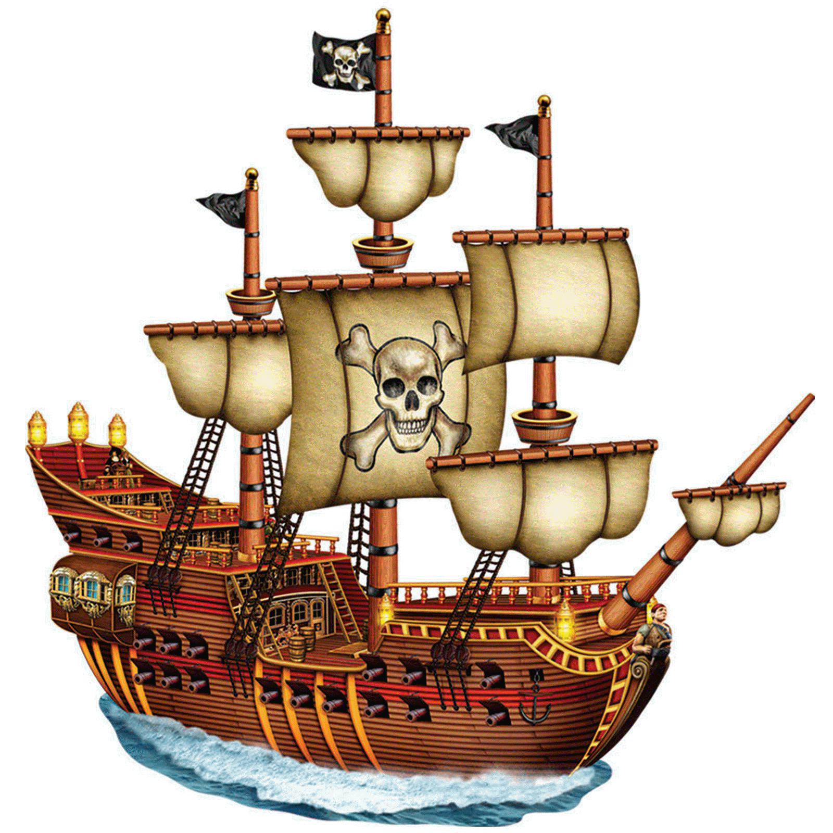
Ingredients:
To be the perfect pirate, you will need:
- 1 powerful, mighty pirate ship
- 100 brave, heroic crew mates
- 500 terrifying, deadly cannon balls
- 10 magnificent, fearsome cannons
- 1 enormous, petrifying Jolly Roger flag

How to make it:
Firstly, you need to place your powerful, mighty pirate ship in the crystal clear, vast Caribbean Sea so you can set sail.
Second, you need to find 100 brave, heroic crew mates who are ready to fight enemy ships to steal treasure, but not too heroic or they won’t help you fight weak, innocent merchant ships.
After that, you need to load your 500 terrifying, deadly cannon balls into your 10 magnificent, fearsome cannons or you won’t be ready to fire when you see an enemy.
Finally, raise your enormous, petrifying Jolly Roger flag so everyone in the sea knows you are the fastest and most powerful pirates on the Caribbean.

How you know it has worked:
You will know it has worked when you have mountains of precious, valuable gold and silver treasure to spend on whatever you want. Also, you will have lots of medicine, soap, fabric and spices because those are important pirate treasures to. Finally, if it has worked then you will be more famous than even Captain Jack Sparrow!

