Date: 25/03/20 Tudor English and Maths answers
5–6 Years English (Year 1)
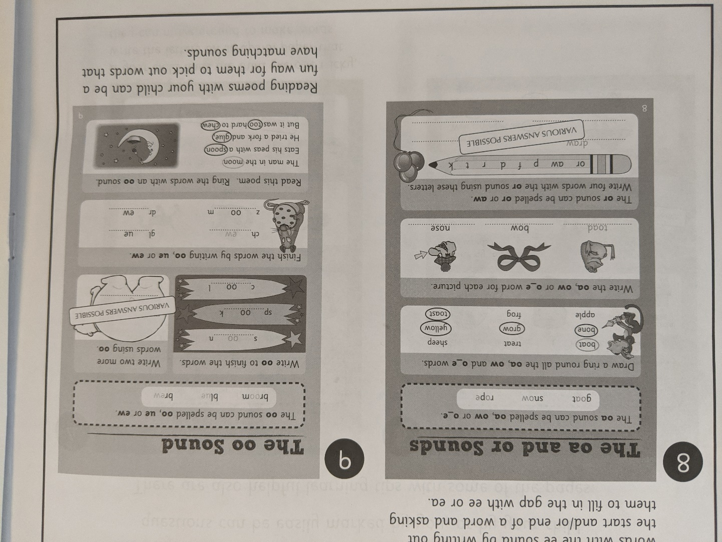
5–6 Years Maths (Year 1)
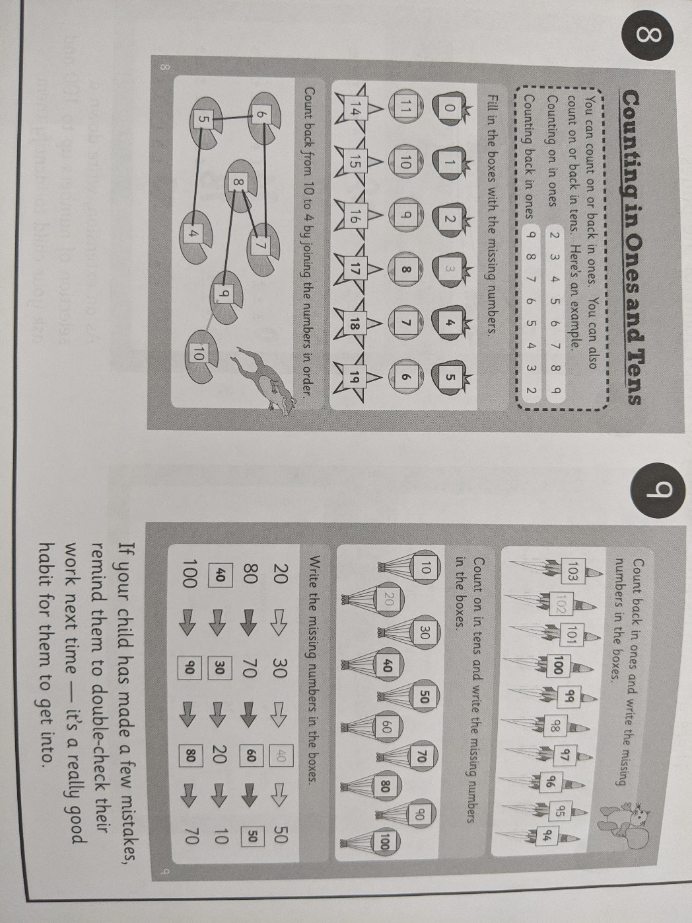
6-7 Years Maths (Year 2)
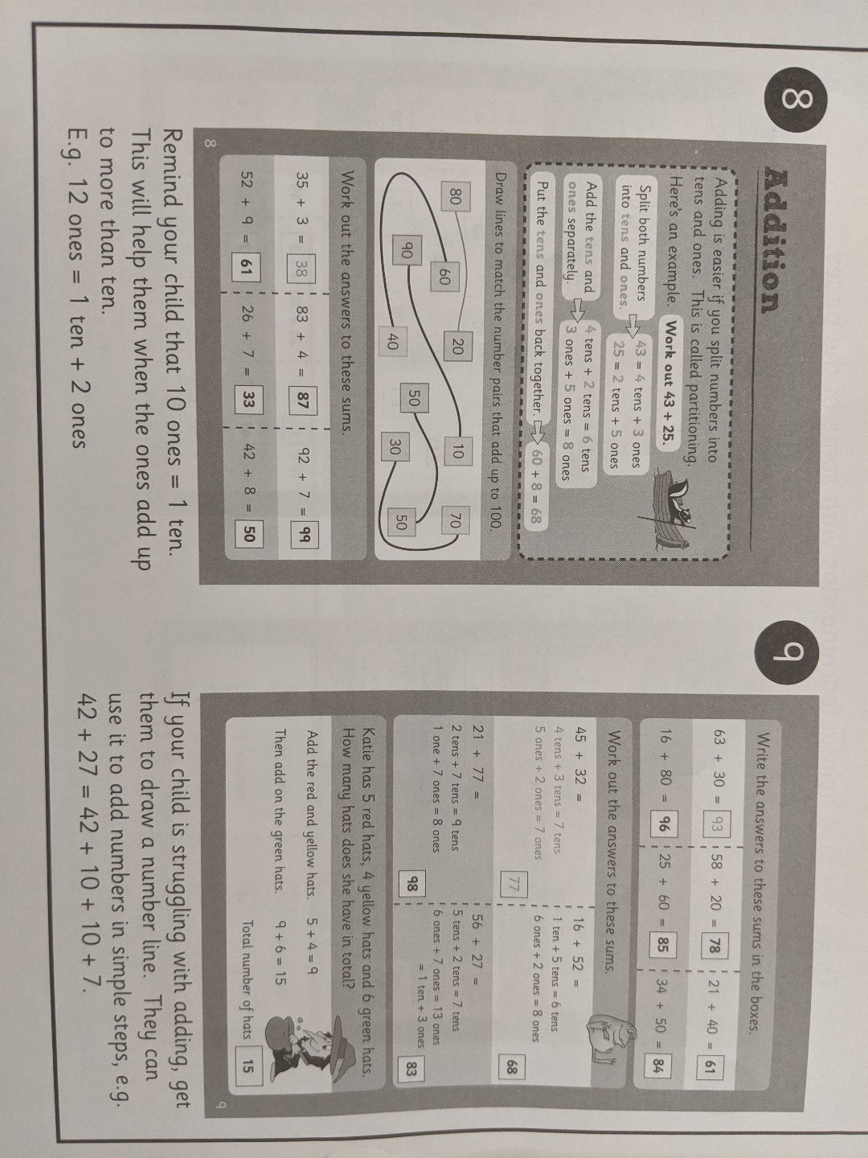
6-7 Years English (Year 2)
