
Redwood Drive
Hemel Hempstead
Herts HP3 9ER
Headteacher: Rob Weightman
Telephone: 01442 256294
Email: head@tudor.herts.sch.uk
_______________________________________________________________________________________
Wednesday 18th December 2019
Dear Parents/ Carers of Year 5
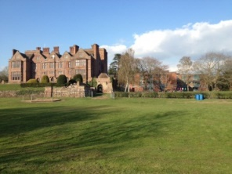
Re: Our Residential Trip to JCA- Condover Hall in 2020

It is time to officially announce our planned trip to JCA Condover Hall for October 2020. Whilst your children are still in year 5, it is time to start sharing the awesome experience that awaits the Tudor Year 6 explorers for next academic year.

The trip will take place during the week from Monday 5th October to Friday 9th October 2020. The children will travel by coach on the Monday morning and they will be able to enjoy a full week of adventurous activity as well as fun games and experiences in the evening. Activities range from abseiling and climbing to fencing and archery. In the evenings there is a full programme of events including fun games, a cinema night and the famous JCA disco evening. It really is the most wondrous week and the feedback from the Tudor children who have visited in the past has been so positive. In fact, it is something that they are sure to remember for the rest of their lives.

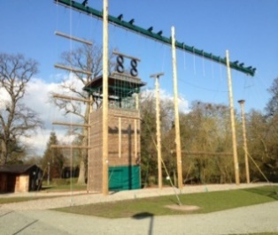
Following feedback, we will not be holding a separate trip information evening this year. Instead we will signpost you to the key information that you need. Please talk to any of the year 6 team if you would like to ask any questions. The year 5 children have been shown a presentation about what is in store and the current year 6 children have shared their feedback too. We hope that every child is able to attend the trip and benefit from such an experience. The JCA brand is market leading and they have a superb track record in delivering residential experiences of the highest quality.

The cost of the full trip including all activities/ accommodation/ insurance and transport is £260. If you would like your children to attend, a deposit of £40 is required by Friday 14th February. If your child receives PPG funding support, please contact the office.

As well as reducing the cost of the trip by nearly 50%, there are a number of other advantages to having the visit in October rather than at the end of the year. The children really do ‘bond’ together as a group and they can then look forward to that final last year together at Tudor. At the end of the year, we will also provide some ‘end of year 6’ fun treats too- more on this to follow!


Do look at the year 6 section of our school website. This contains information about JCA and other web-links that highlight the fantastic experience that await the Tudor party.

If you would like your child to attend, please complete the slip below by Friday February 7th. Deposits can be paid via school gateway or the school office.

Mr Munro- Group Leader of the Tudor 2020 Residential to JCA- Condover Hall

To the Tudor School Office,

I would like my child ________________________________________ to attend the 2020 year 6 residential to JCA- Condover Hall.

I have paid the £40 deposit via SchoolGateway _____ I attach a cheque for £40 as deposit _____
(Make payable to Tudor Primary School)
Signed______________________________________________

