Date: 23/03/20 | Circle
English
IDL Literacy
Spelling shed
Reading
Lexia
60 second read – How to build a snowman
Maths
IDL Maths
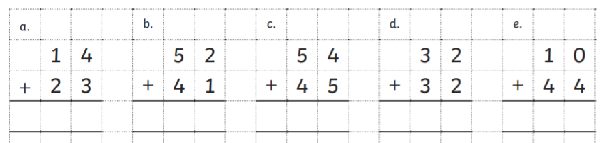
Topic
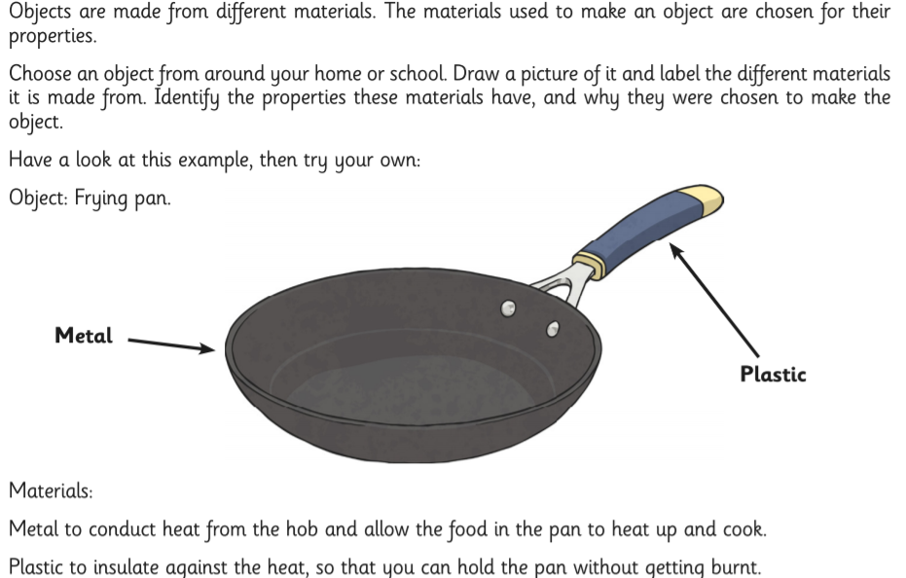
Positive news
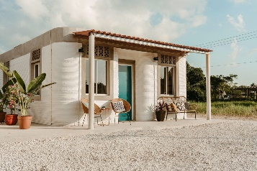
Could 3D-printing help to tackle homelessness and provide affordable housing to those in need?
Rural families in the region of Tabasco in south Mexico have been given new homes thanks to a project that is building the world’s first 3D-printed neighbourhood. It is the work of US-based non-profit New Story, which has partnered with a 3D-printing technology company to build the 500sq ft homes for a community living in poverty.

