Date: 23/03/20 | Square
English
Spelling shed – Phase 5/6
CGP – p. 4 Commonly Confused words, p.6 Word Endings
Spag.com – Probability words
Reading
60 second read – Help, I’m Stuck!
Maths
Maths shed – Negative numbers
CGP – p. 4 Place Value & Ordering, p. 6 Written Addition
Challenge:
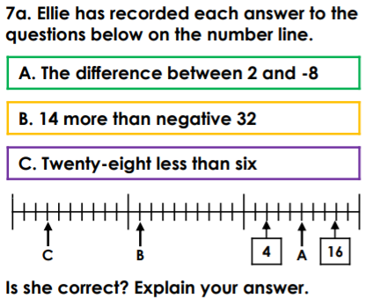
Topic
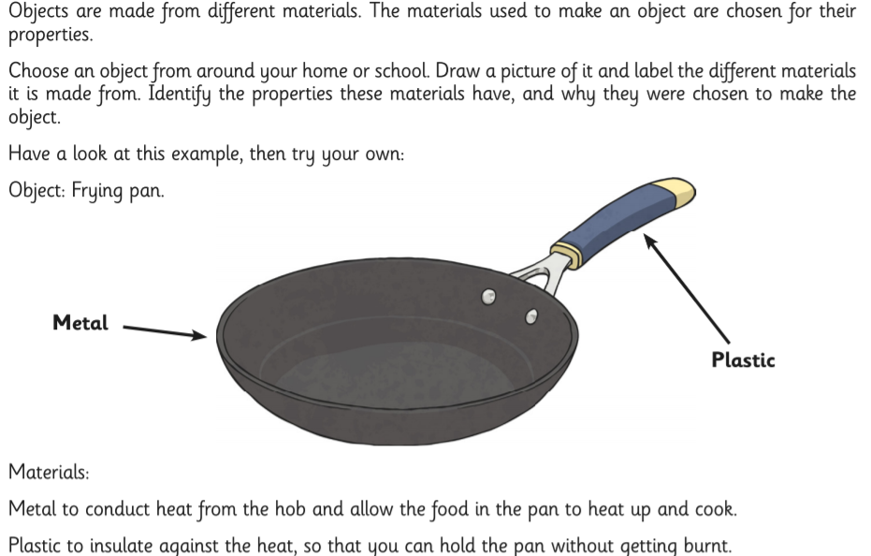
Positive news
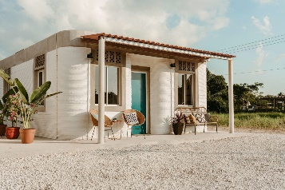
Could 3D-printing help to tackle homelessness and provide affordable housing to those in need?
Rural families in the region of Tabasco in south Mexico have been given new homes thanks to a project that is building the world’s first 3D-printed neighbourhood. It is the work of US-based non-profit New Story, which has partnered with a 3D-printing technology company to build the 500sq ft homes for a community living in poverty.

