Date: 24/03/20 | Square
English
Spelling shed – Phase 5/6
CGP – p. 8 Changing Word Types
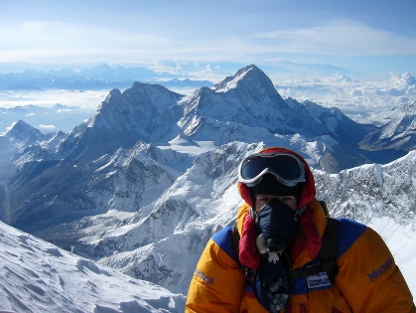
Writing – Imagine you are Edmund Hillary, the first man to climb Mount Everest. Write a diary entry from his perspective either from the day before or the day after he reaches the summit.

Dear diary,
…
Reading
60 second read – Metamorphosis
Maths
Maths shed – Times tables (4,6,7,8) Mixed
CGP – p. 7 Written Subtraction
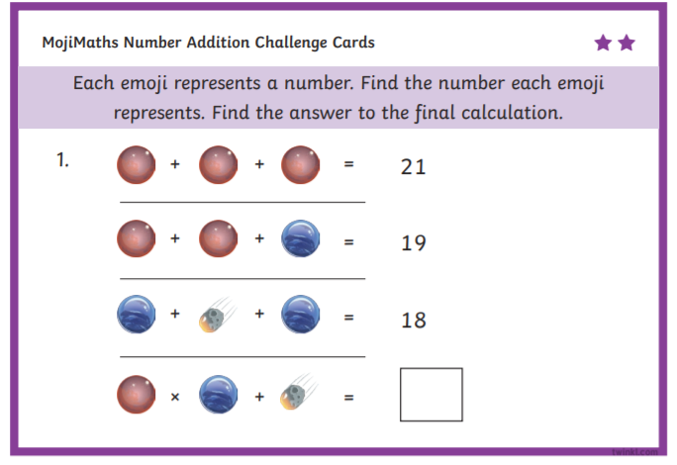
Topic
Design a flag for our class that we would bring to the top of Mount Everest if we were to climb it. Think about what would represent our class the best.
Positive news
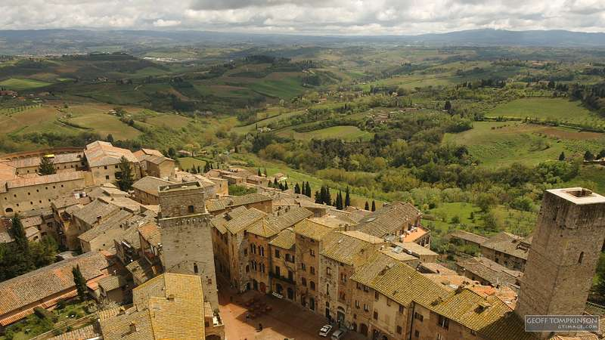
Italy will become the world’s first country to introduce mandatory climate education in state schools!

Public schools in Italy will soon be required to offer one hour of climate-related lessons per week. The move, which will come into effect in September, makes Italy the world’s first country to introduce mandatory climate education in state schools. Subjects such as physics and geography will also be taught from a sustainability angle.

