Date: 25/03/20 Tudor English and Maths answers
5–6 Years English (Year 1)
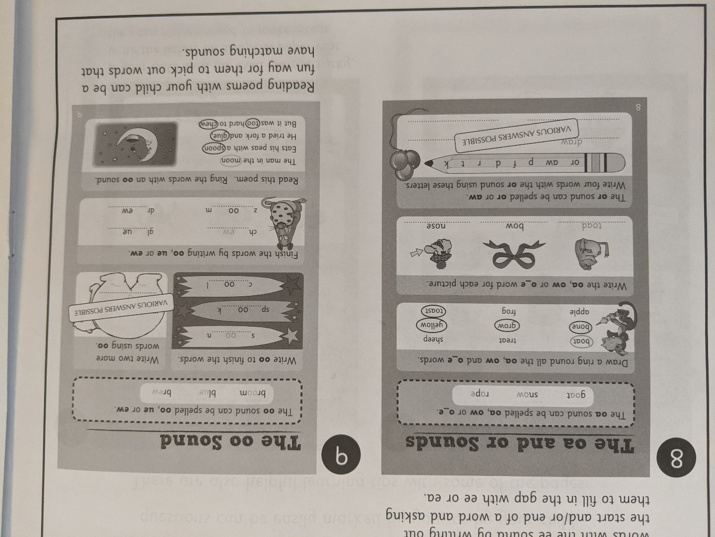
5–6 Years Maths (Year 1)
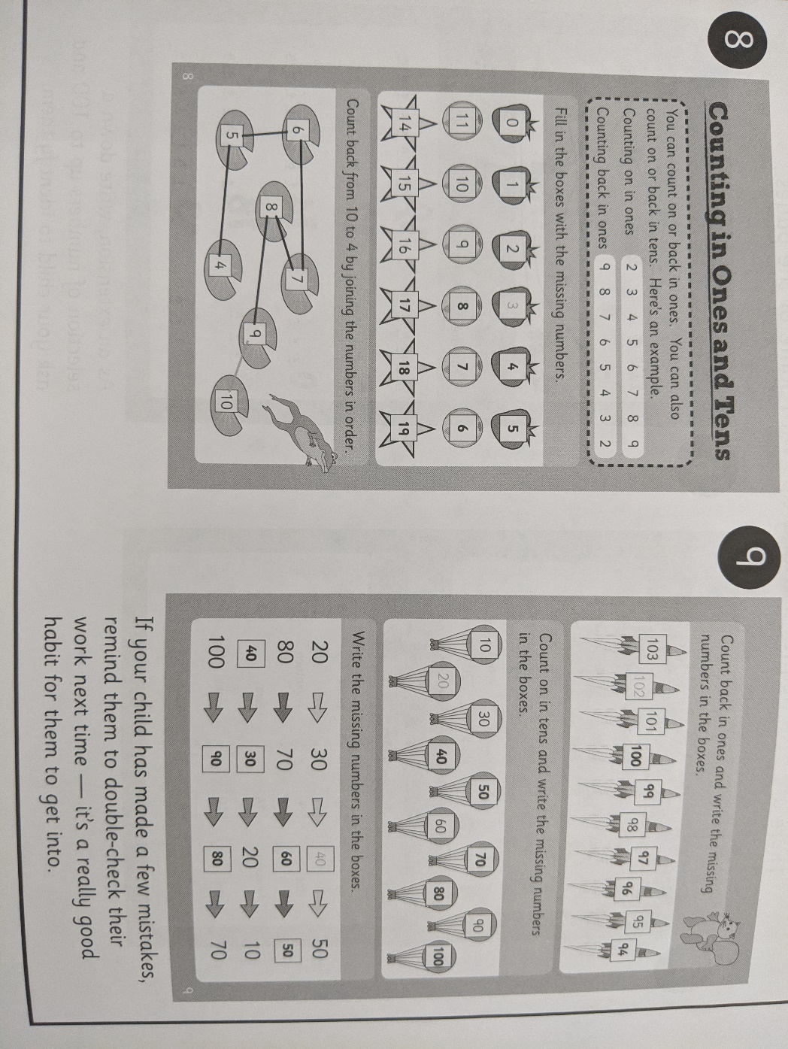
6-7 Years Maths (Year 2)
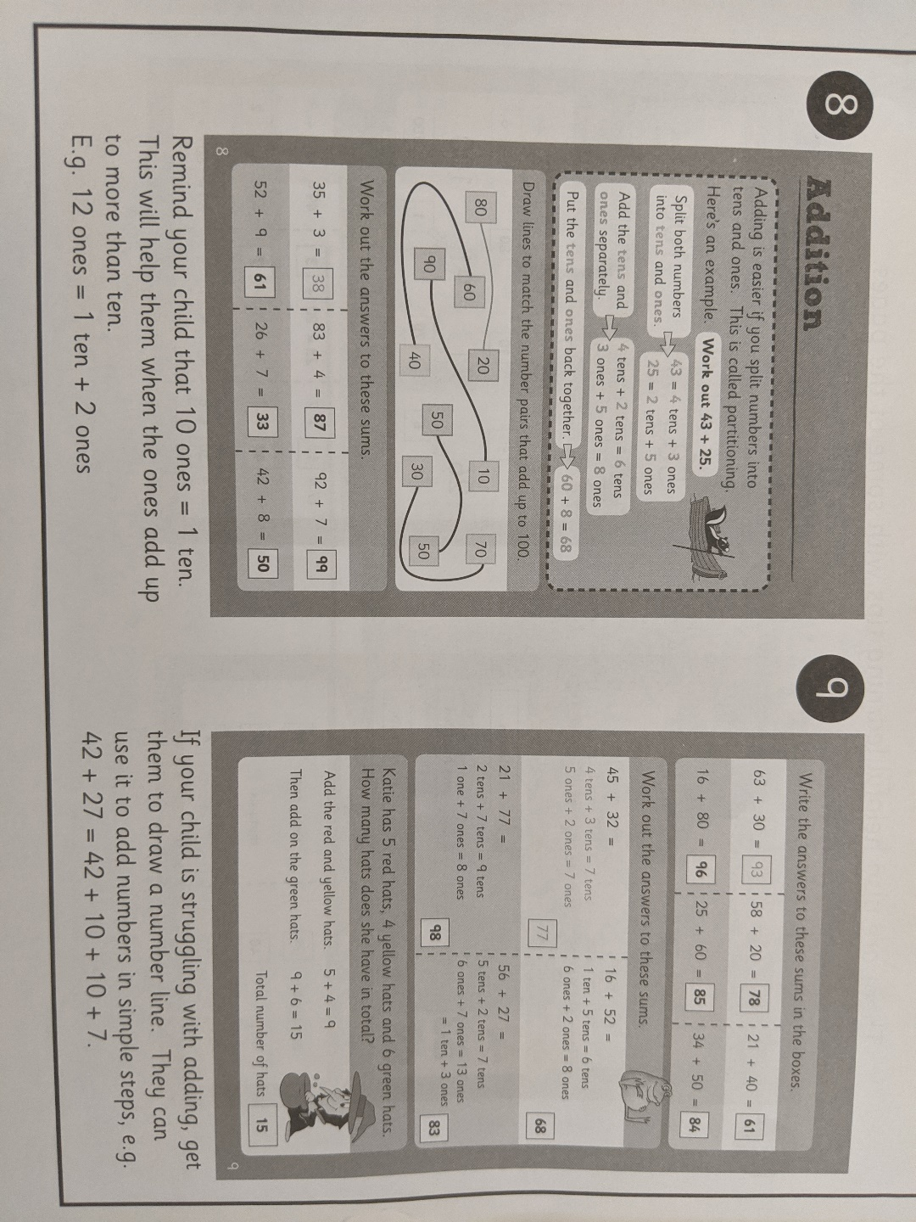
6-7 Years English (Year 2)
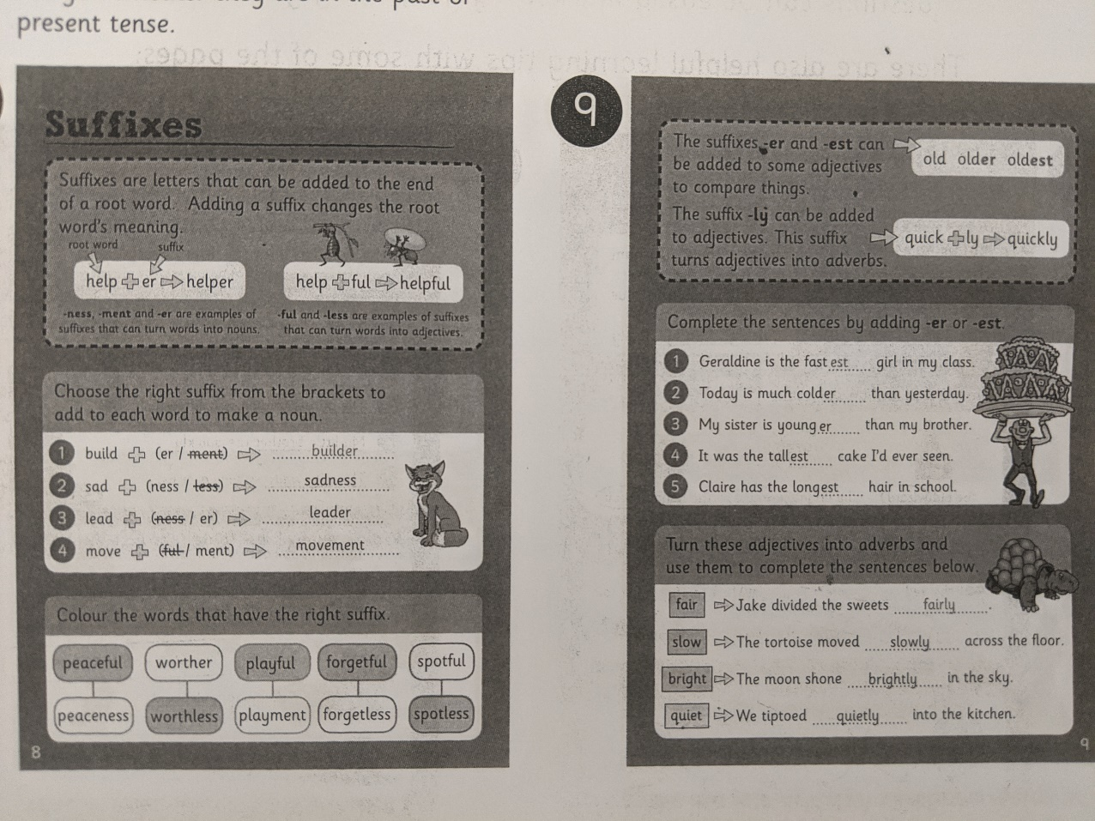
7–8 Years English (Year 3)
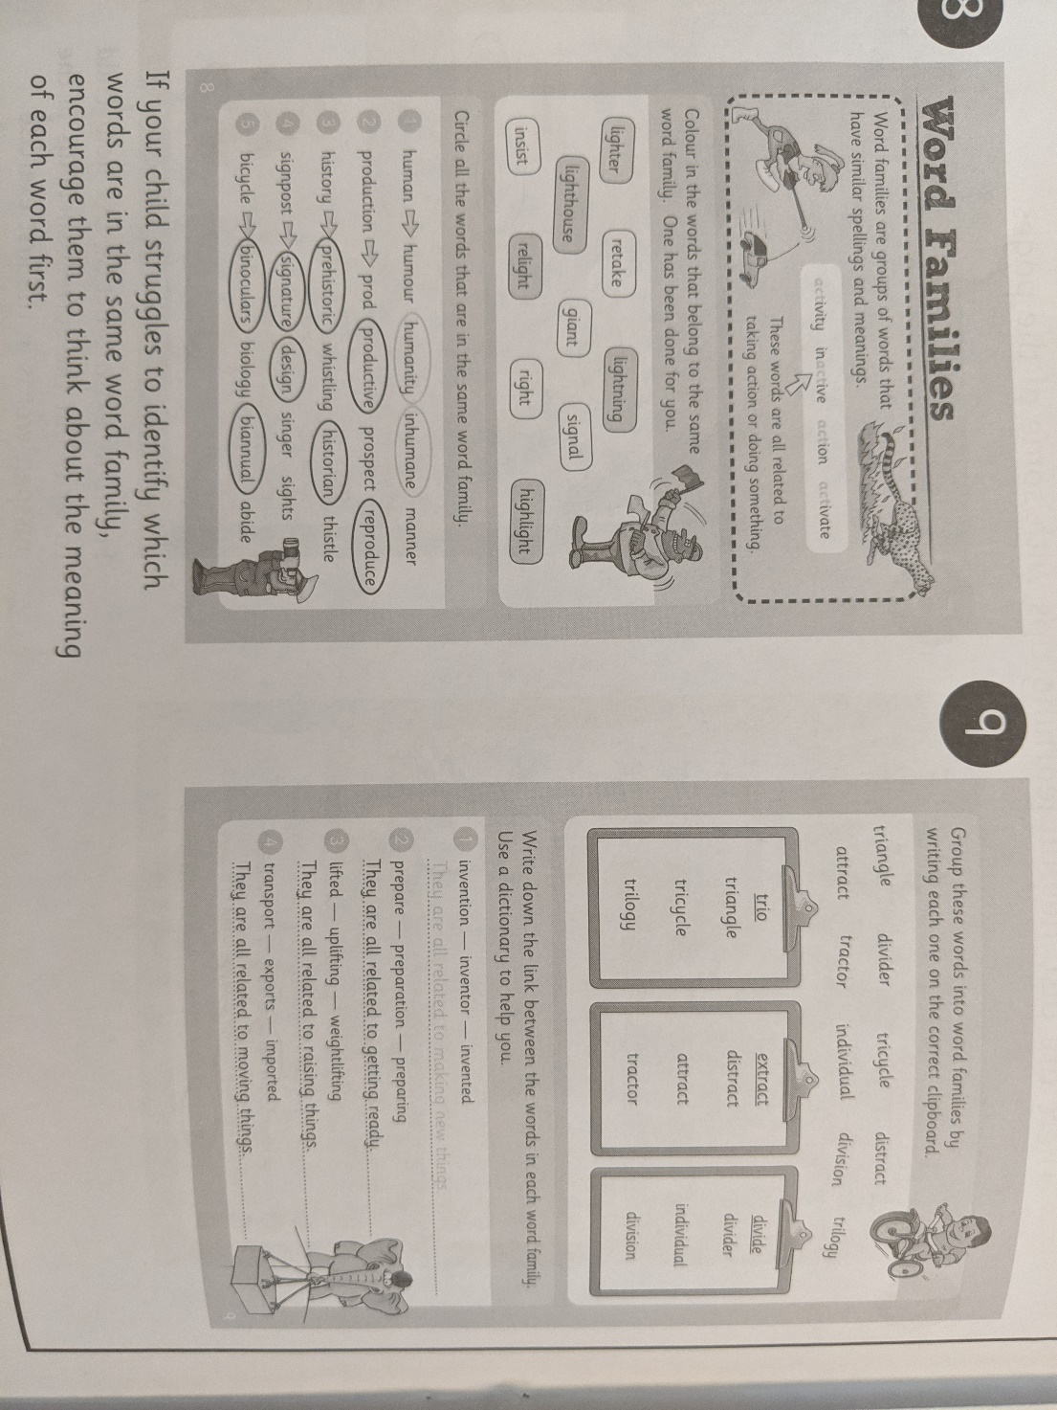
7–8 Years Maths (Year 3)
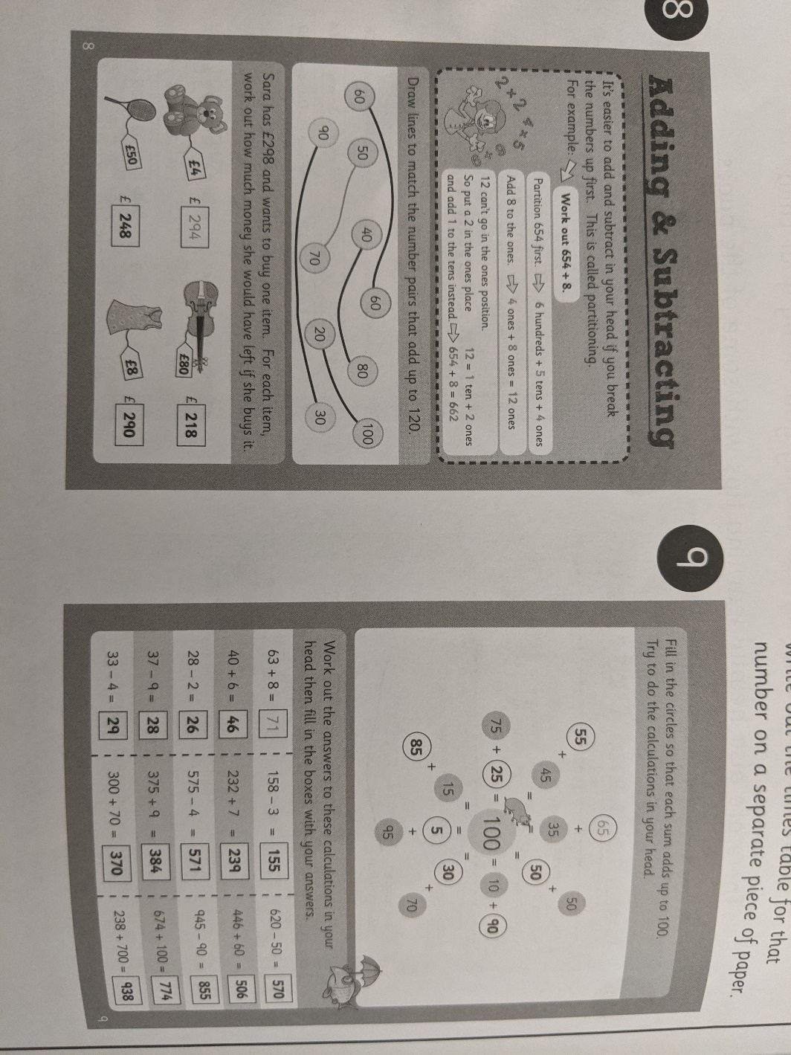
8-9 Years English (Year 4)
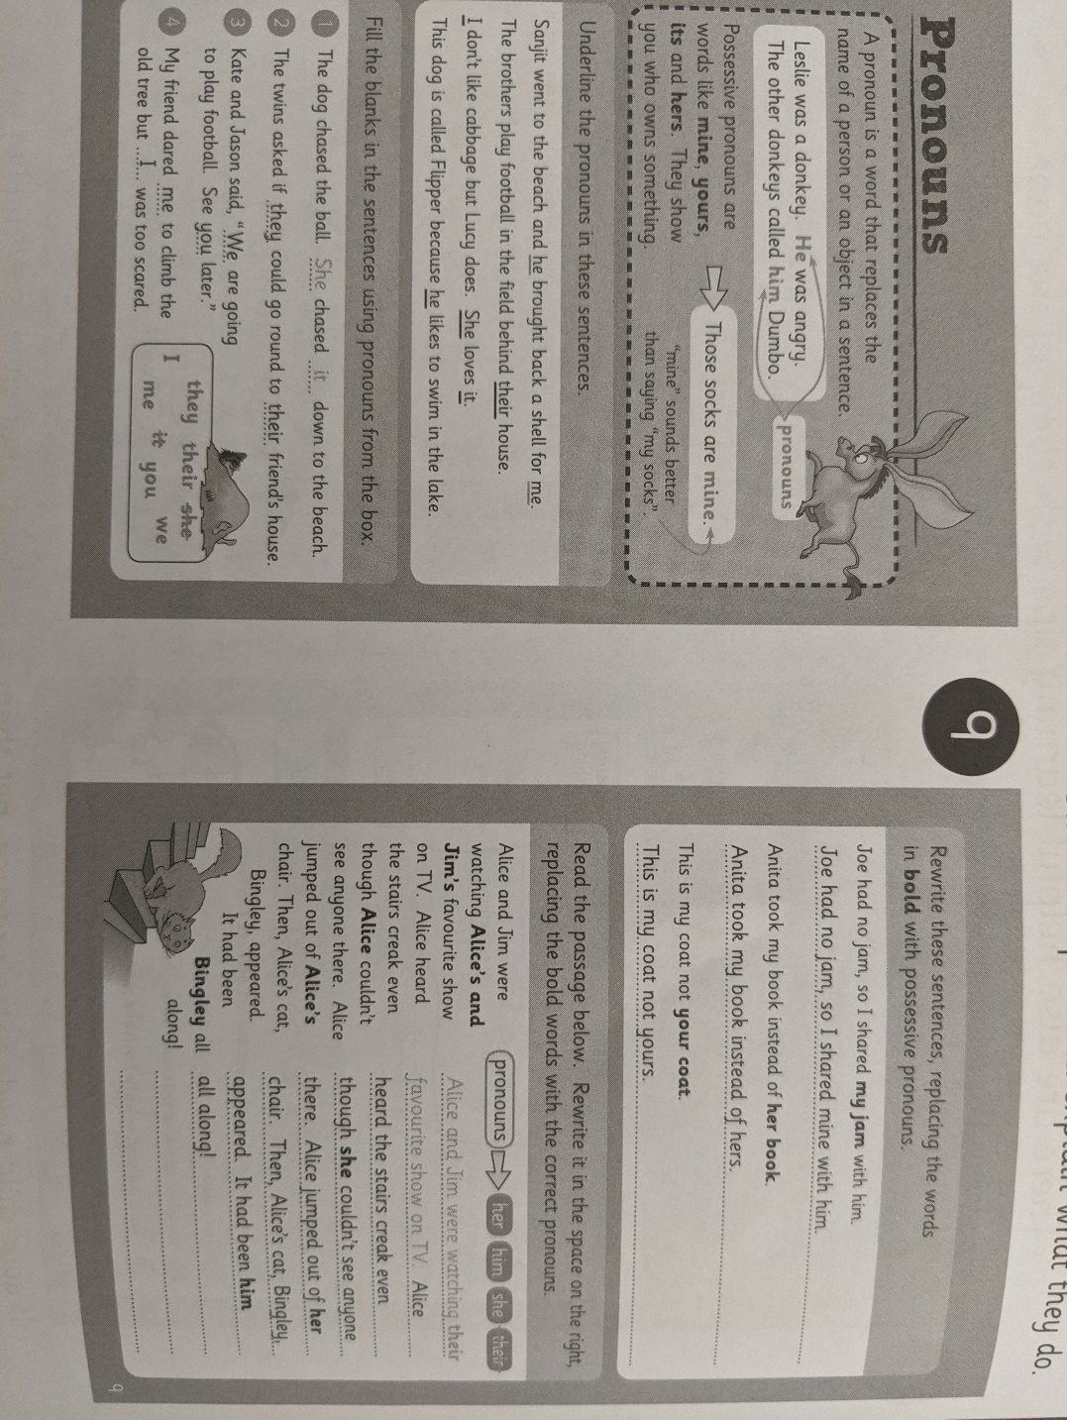
8-9 Years Maths (Year 4)
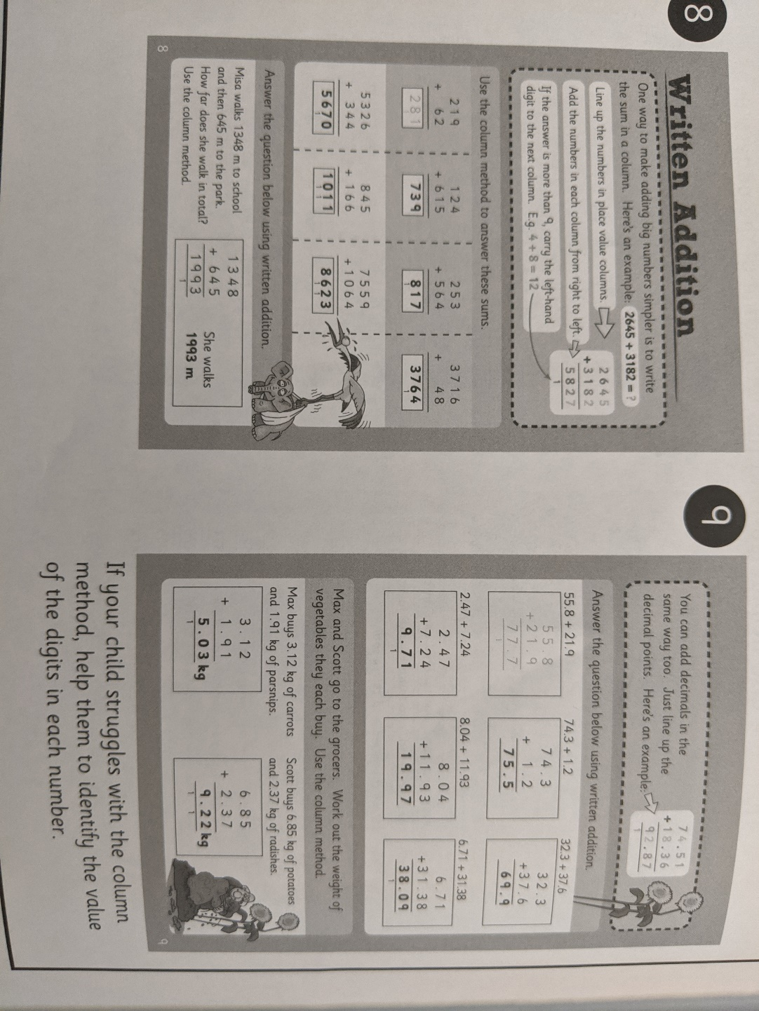
9-10 Years English (Year 5)
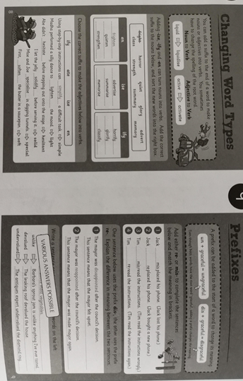
9-10 Years Maths (Year 5)
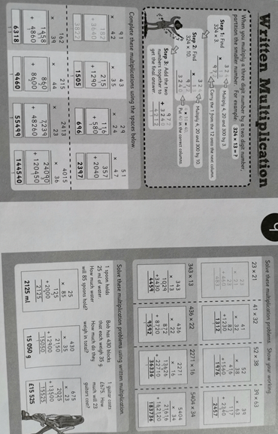
10-11 Years English (Year 6)
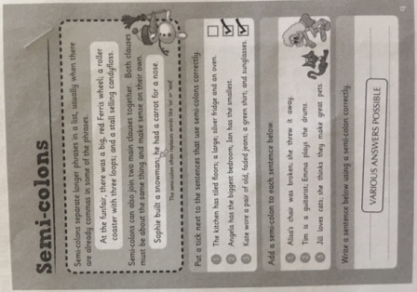
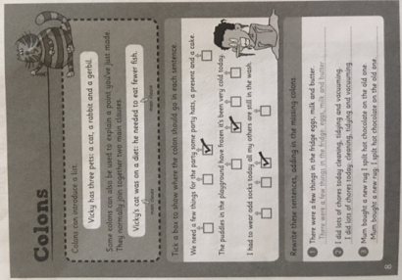
10-11 Years Maths (Year 6)
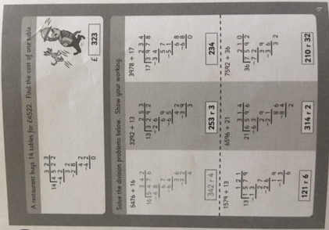
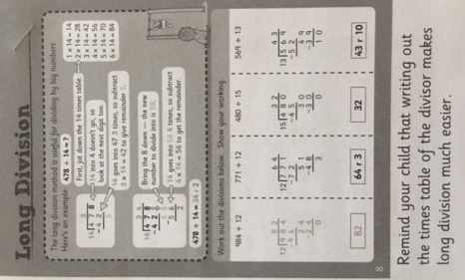
10-11 Years Reading (Year 6)
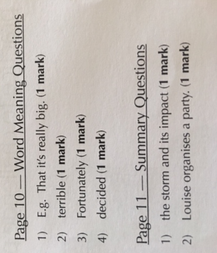
Prediction question is up to you but you must have APE’d or PEP’d you answer

