How to be the perfect Pirate

Do you want heaps of gold? Do you want to be a famous Pirate? Do you want a golden ship that sails itself? Do you want the biggest ship in the Caribbean? Follow these instructions then you will be the best Pirate.
Ingredients
- 1 strong ship.
- 2000000 crew members
- 40 cannons
- 900000000000 cannon balls
- 1 good captain
How to make it
Firstly, you need to find 2000000 pirates for your crew. Secondly you need to find 900000000000 cannon balls. Next you need to find 40 cannons. Next you need to find 1 strong ship. After you need to find a captain.
How you know it has worked
You would have 10000000000000000000000 gold and silver!!!

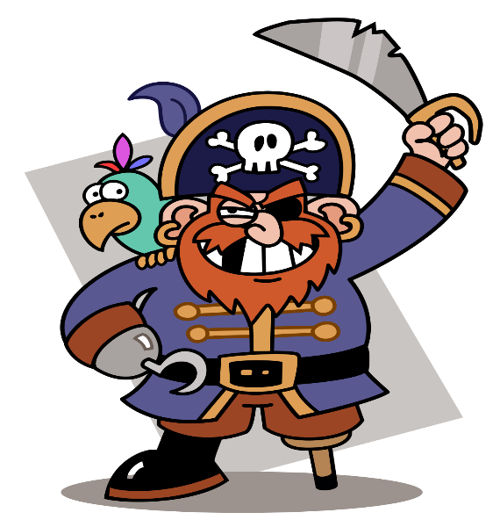
This Photo by Unknown Author is licensed under CC BY-SA

