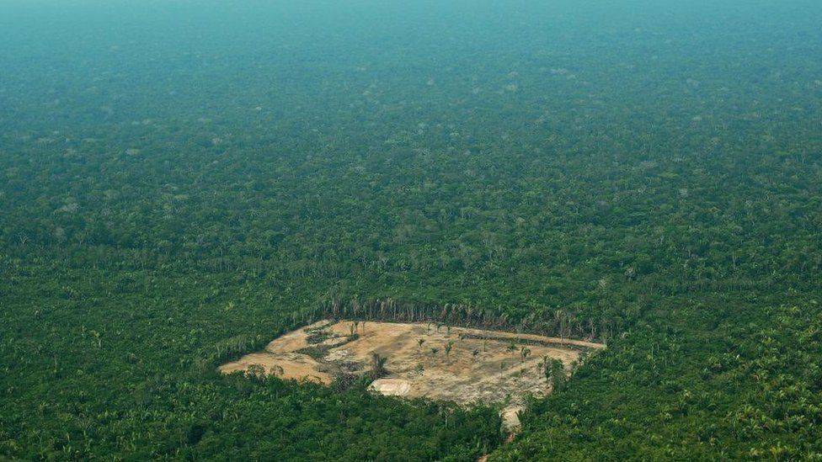

The Amazon rainforest is the largest rainforest, and stretches into nine different countries (Brazil, Ecuador, Venezuela, Suriname, Peru, Colombia, Bolivia, Guyana, and French Guiana.) Rainforests are home to 50% of animals and plants and 10% of the worlds known species, but only covers 2% of the worlds surface area.

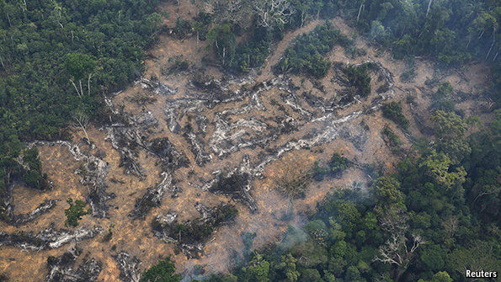

The Amazon rainforest at the moment this will get more severe if we continue to cut them down.
We get lots of our resources from the such as wooden furniture (tables, chairs, desks, wardrobes and drawers) and lots of medicines.
Today there are still a few trees, but they are extremely rare and should not be used as such usage will encourage harvesting and the ultimate end of this species, other historic common names for Cuban mahogany are Caribbean mahogany, West Indian mahogany and Santo Domingo mahogany
Other historic common names for Cuban mahogany are Caribbean mahogany, West Indian mahogany and Santo Domingo mahogany.
You may think crawl, there are many different ways why people do this. Some people who live in poor countries or are poor themselves and need money to get food and shelter they cut trees down and sell them. Another reason people cut down trees are to get land for food and cattle farming. But people do this for their own reasons.

Only cut down rainforests if you must because in a hundred years or so there might not be any rainforests left.
It takes one person to make a change it takes all of us to make a difference.

Deforestation is happening quicker than you may think. In every 20 minutes approximately 20 football pitches have been cut from rainforests across the world. How long will rainforests stand?

