S
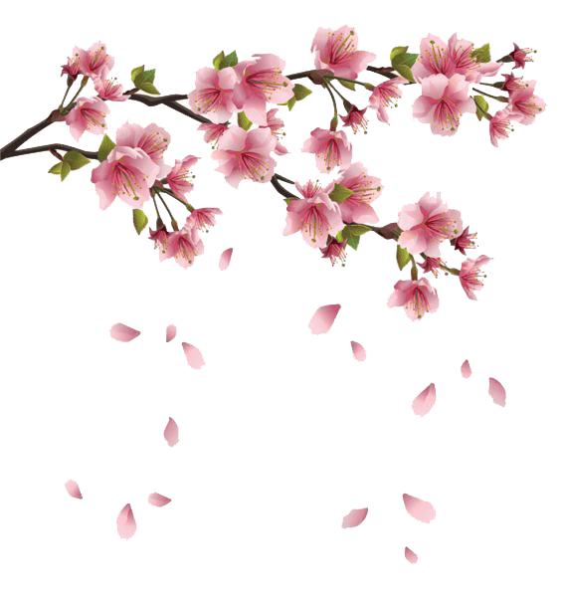
eason of birth and a fresh start for all

P
romising times of positivity and happiness

R
eligious celebrations of life and rebirth.

I
ncredible creatures coming out of hibernation

N
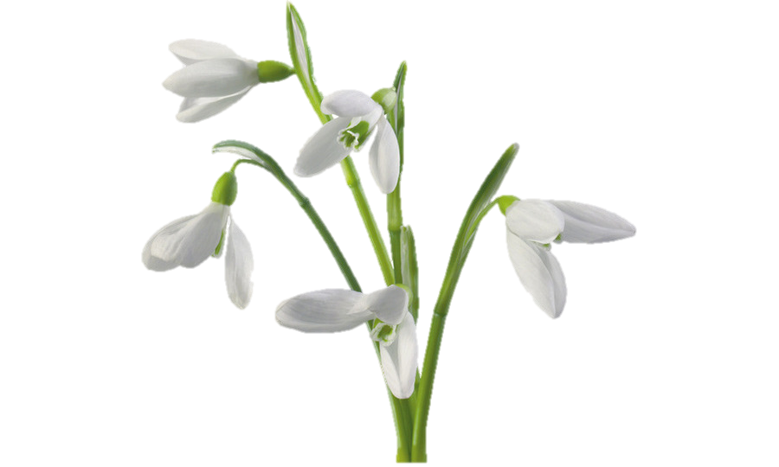
ew life for animals and plants everyday

G
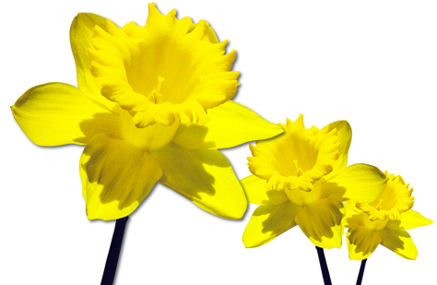
rowth and majesty for natural beauties.

