Read pages I , II, III
1. What do you think the poem is about? It tells the story of a highwayman who falls in love with Bess, a landlord's daughter
2. What do you think ‘the wind was a torrent of darkness’ means? The first line of the poem simply means that it was very dark and windy on that fateful night when the highwayman came riding up to the old inn-door.
Torrent meaning: a strong and fast-moving stream of water or other liquid.
3. Why did the author repeat the word riding? Repetition is meant to draw your attention. It's essentially the writer pointing at an idea, a word, or an action, and saying look at this!
4. List three things that the Highway man was wearing. French cocked-hat, lace at his chin, coat of the claret velvet, breeches, boots.
5. List three sets of rhyming words. (trees, seas) (moor, door) (chin, skin) (thigh, sky) (yard, barred) (there, hair)
6. Find and copy an example of alliteration. Ghostly galleon, cobbles he clattered.
7. What do you imagine when you read ‘the road was a ribbon of moonlight’? The metaphor compares the road to a ribbon of moonlight – a windy road light by the moonlight.
8. Where was the Highway man riding to? Old inn door – to the inn.
9. What fabric was the Highway man’s coat made from? Claret velvet
10. Find and copy the phrase that tells you the Highway man’s boots were tight. They fitted with never a wrinkle.
11. What is the rhyming pattern in the poem? AABCCB

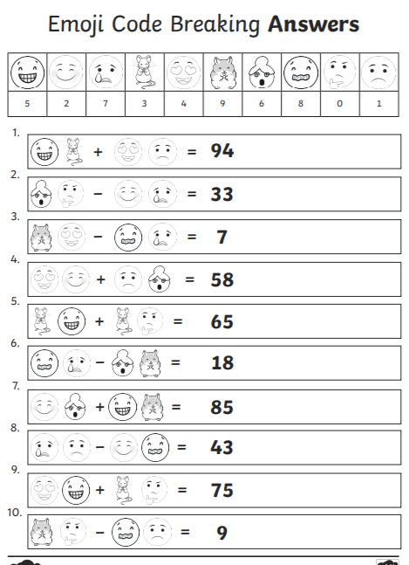
1 Star Challenge

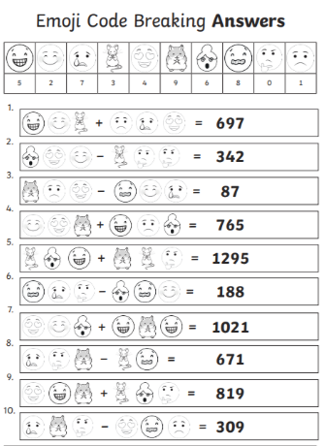
2 Star challenge

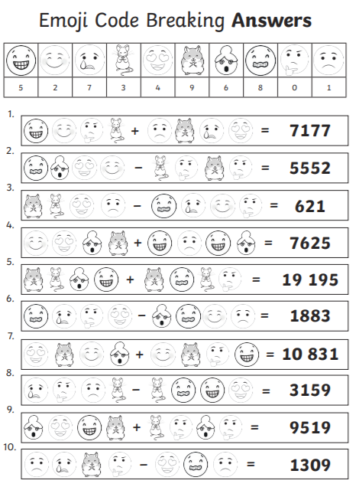
3 Star challenge

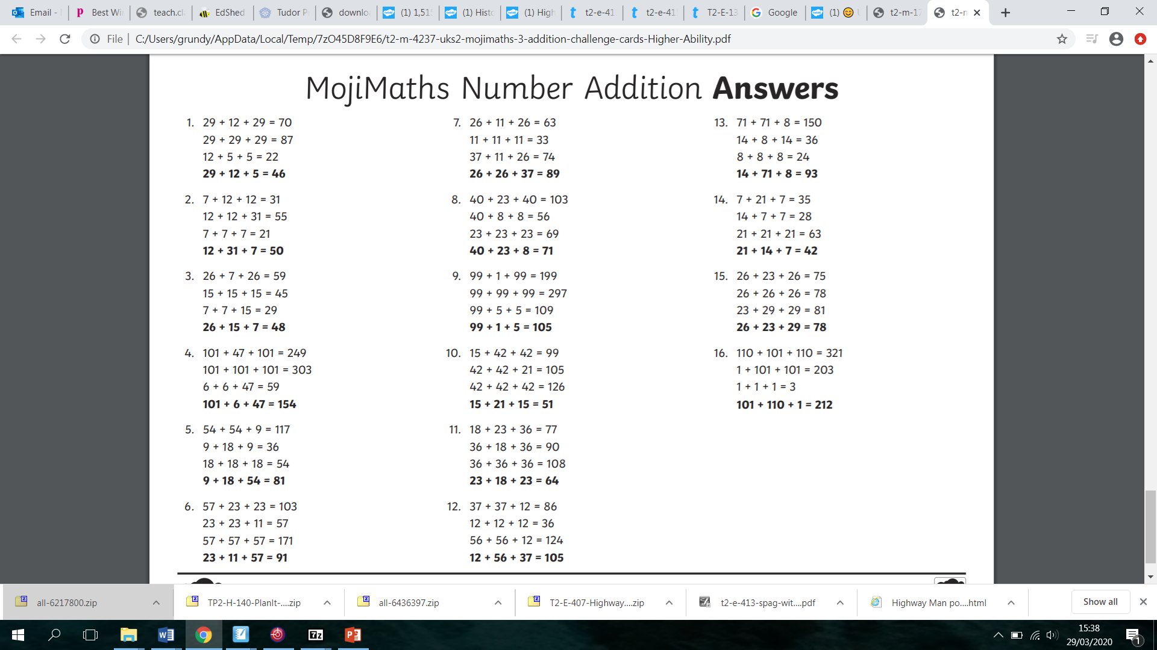
4 Star challenge

