One star
Use counters, cubes or other objects you can find in your house to solve these questions –
Remember the denominator (bottom number) tells you how many equal groups and the numerator (top number) tells you how many of the groups.
1/4 of 12
1/3 of 15
1/5 of 20
1/2 of 8
1/4 of 8
1/10 of 20
1/4 of 20
1/6 of 18
1/3 of 18

Two star
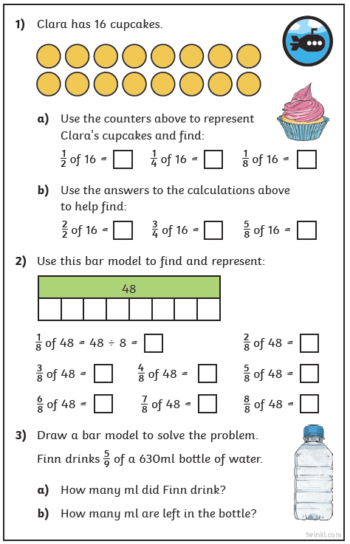
Three star extension


