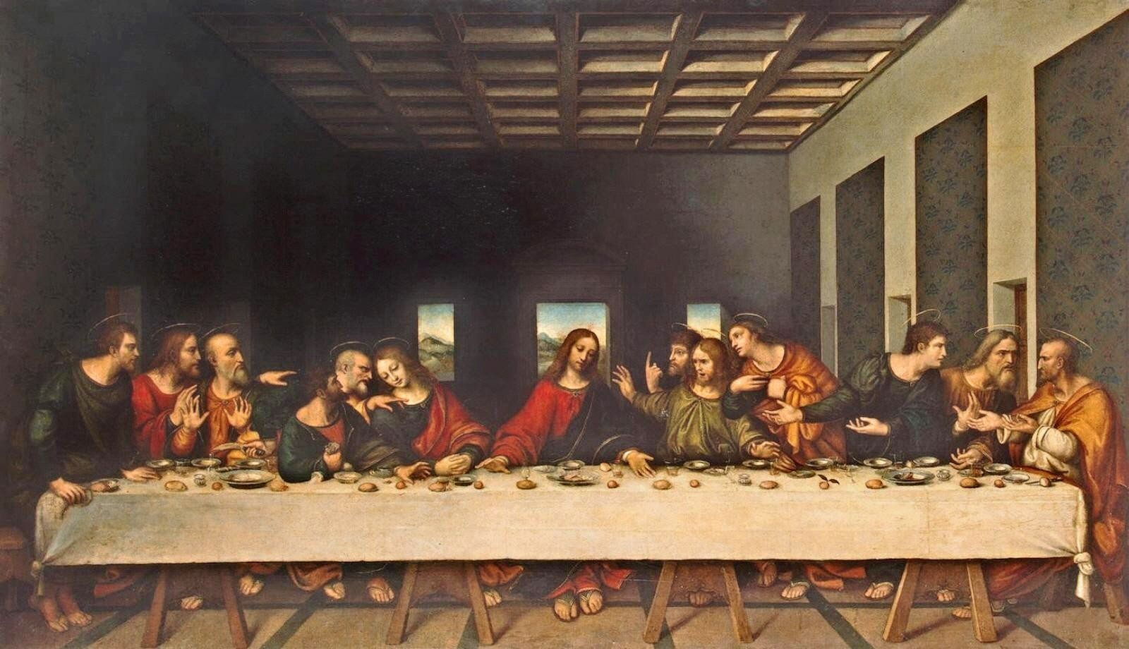
The Last Supper

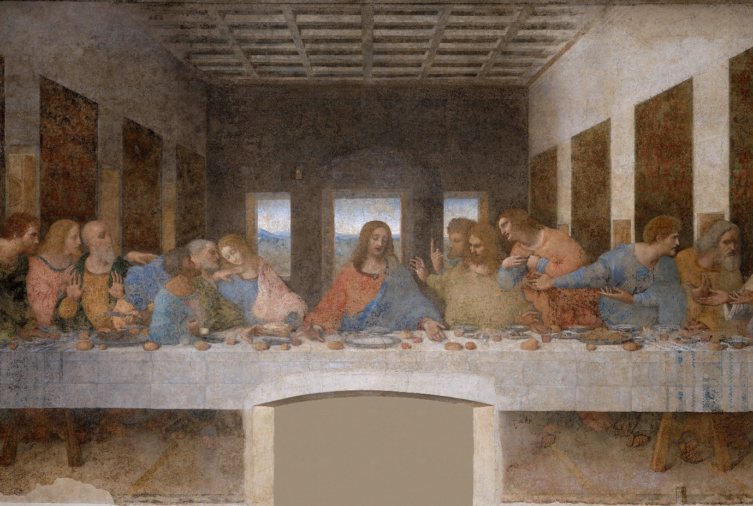

What questions might the people in the image ask Jesus or others around the table?
Why are there several pictures of the Last Supper? Try researching one of the paintings of the Last Supper and the artist.

