
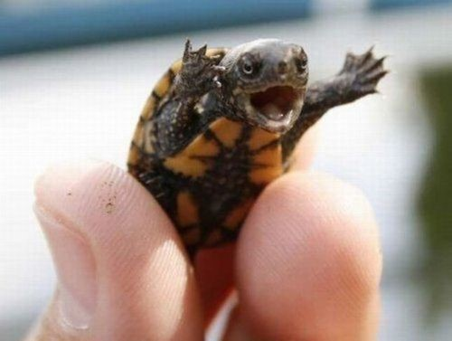
This turtle is deciding to make history by being the first of its kind to run for president of the United States of America. This is the life-changing speech he delivers to the nation whilst upon the podium of power.

Our world is in pain. Epidemics, crime, climate change are a few of the many problems we face daily. We need to change. We need to put stricter rules in place. We need to stop asking and start telling.
Every decision ever made has altered reality. Anything that has been or will be done will influence. No matter how substantial the decision being made may seem, it will always make an impact on another. No matter how great it may seem, the impact will be there
To make this country what it once was, we need to stop the corrosive decisions, eating away our country. To do this, we need to cut down on fossil fuels. From 2021 onwards, the production of non-electric cars will be prohibited. From 2023 onwards, the usage of any non-essential item giving off carbon monoxide will be forbidden.
For those of you who believe that this is exceedingly strict, your opinion will be valued. Before any significant alterations are made, the public shall vote on the advantage of the action. This country shall have what it has needed for decades: democracy.

