One star
Use counters, cubes or other objects you can find in your house to solve these questions –
Remember the denominator (bottom number) tells you how many equal groups and the numerator (top number) tells you how many of the groups.
1/4 of 12 =3
1/3 of 15 =5
1/5 of 20 =4
1/2 of 8 =4
1/4 of 8 = 2
1/10 of 20 =2
1/4 of 20 =5
1/6 of 18 =3
1/3 of 18 =6

Two star
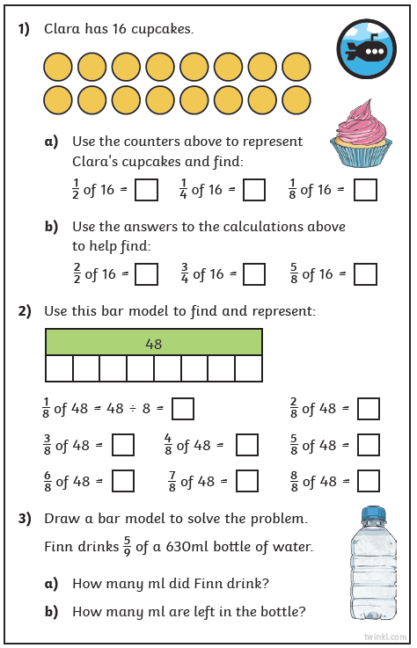
Answers
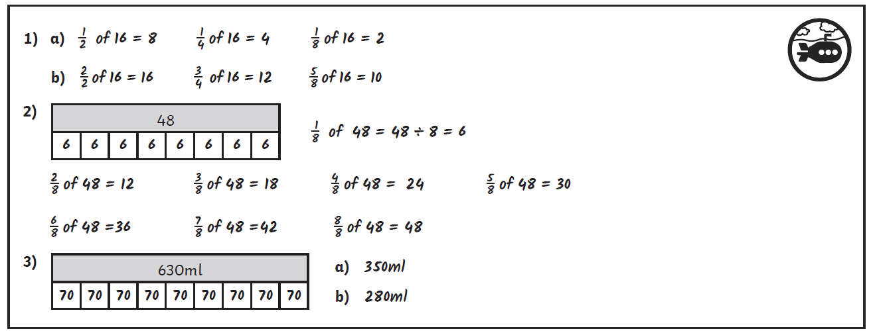

Three star extension
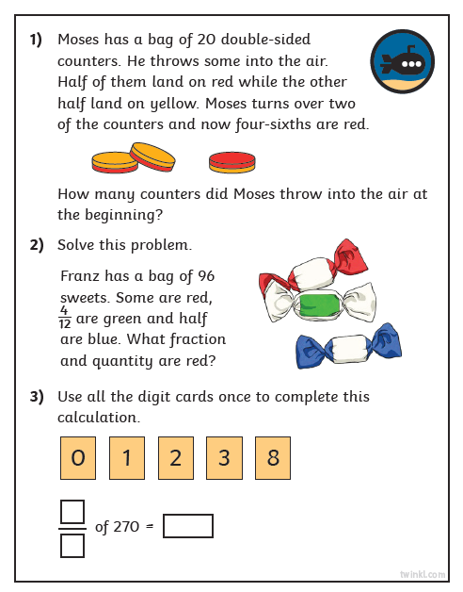
Answers


