Noah Mead

COme and join us
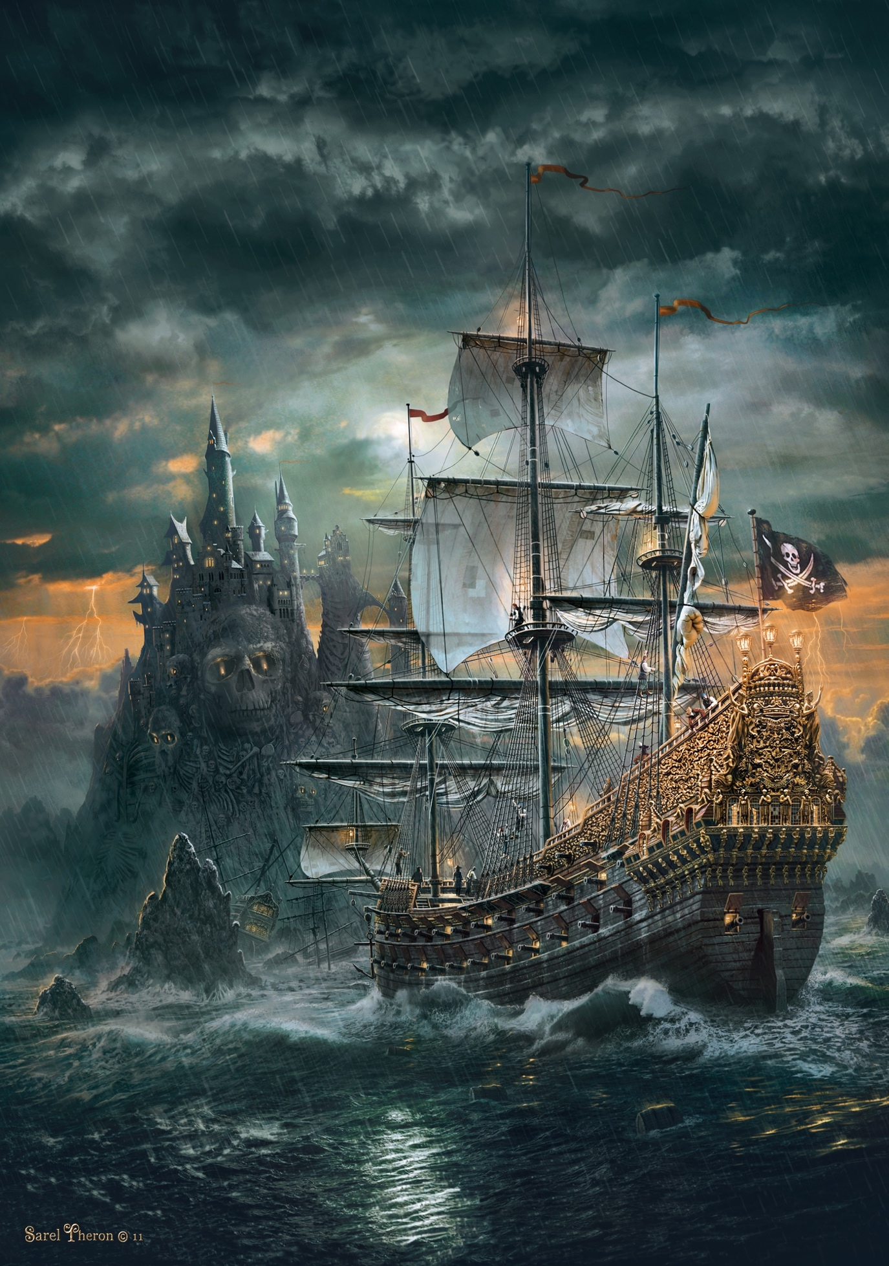
Are you a bored, savage pirate that wants to sail the Caribbean but other pirates say you are not a good enough pirate?
Do you want to be on a great, famous pirate crew that will make you a way better pirate than ever!?
If you want that to happen to you then join are amazing, fabulous crew and all your dreams will come true.
We are the best ship history has ever known and we have the best things for you to do on our ship. You can go and join us pirates in battle, find buried treasure and much more that you can think of!
If you want to join meet our pirate ship on Sunday 5Th April 2020 at 6:45. We will be on the shore of Cornwall.

