Read pages’ part two I, II, III
1. At what time of day is ‘the dawning’? The transition from night to day. About 6am
2. What does o’ mean? Short for ‘of’
3. Find and copy the phrase that tells you the daughter was tied to the bed. Bound her to the foot of the narrow bed.
4. What is a casement? Do not use Google or a dictionary. Use the text to help you answer. A window or part of a window.
5. What do you think the phrase ‘there is death at every window and hell at one dark window’ means? King Georges men are standing at every window ready to shoot the Highway Man, and Bess was tied up looking through one window were the highwayman was tapping the night before.
6. Who do you think the dead man speaking is? Highway man
7. When will the ‘dead’ man attempt to save the daughter? At moonlight

Maths
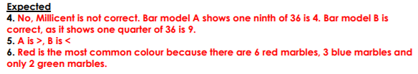
1 star
2 star
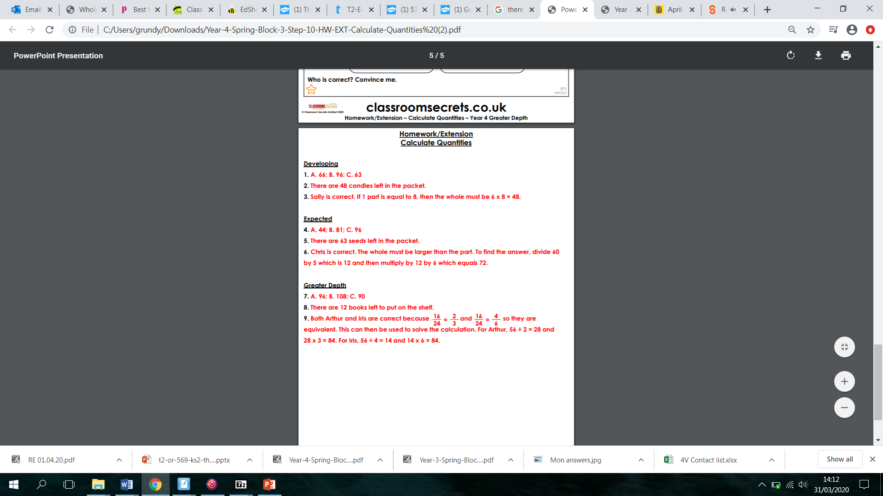
3 star

