One star challenge
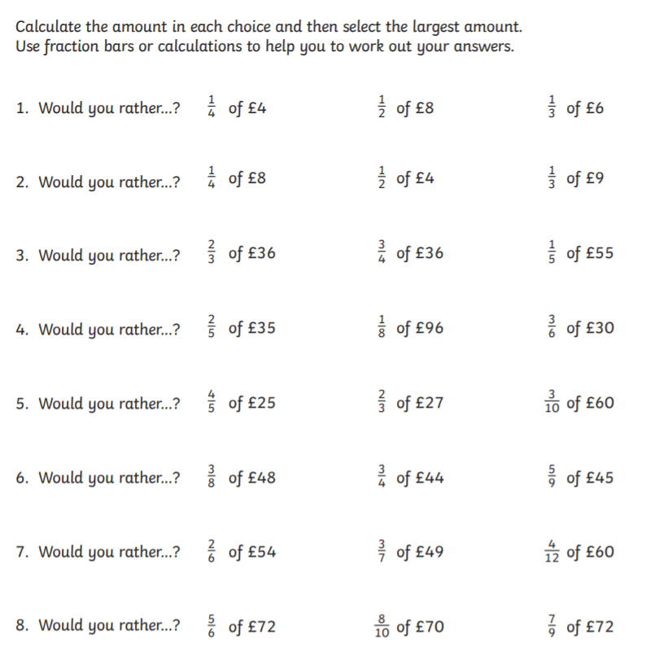

Two star challenge
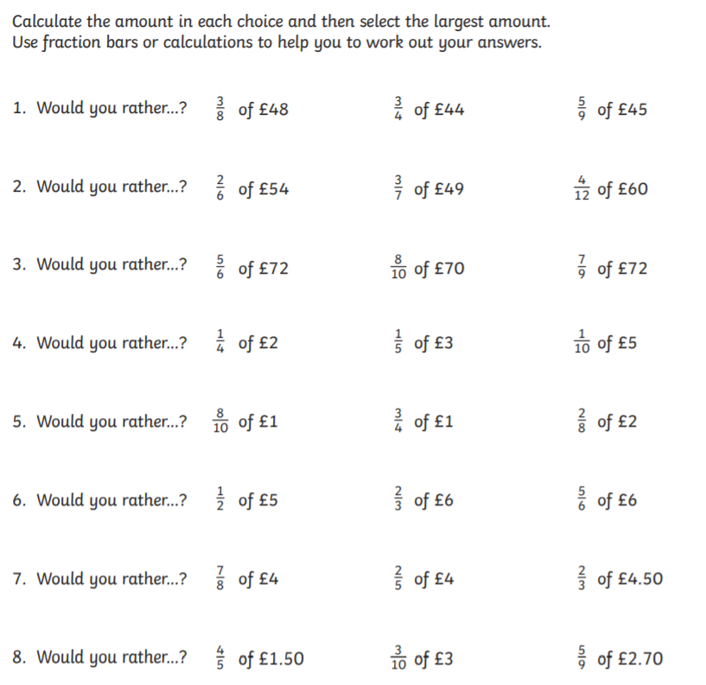

Three star challenge
Would you rather......
Have 10% of £5 or 75% of 80p?
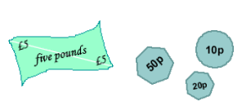
Be given 60% of 2 pizzas or 26% of 5 pizzas?
Be bitten by 15% of 120 mosquitoes or 8% of 250 mosquitoes?
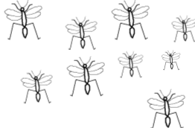
Skip using a rope which is 54% of 105cm long, or 88% of 2.75m long?
Sit in a traffic jam for 33% of 2 hours or 44% of 1hr 40mins?
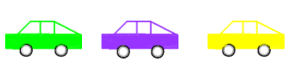
Make sure you explain your reasons clearly.

