One star challenge
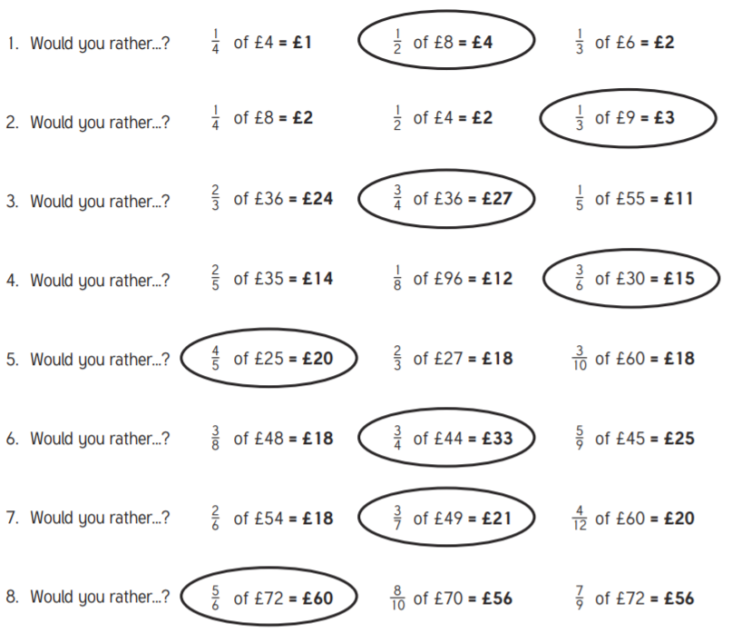

Two star challenge
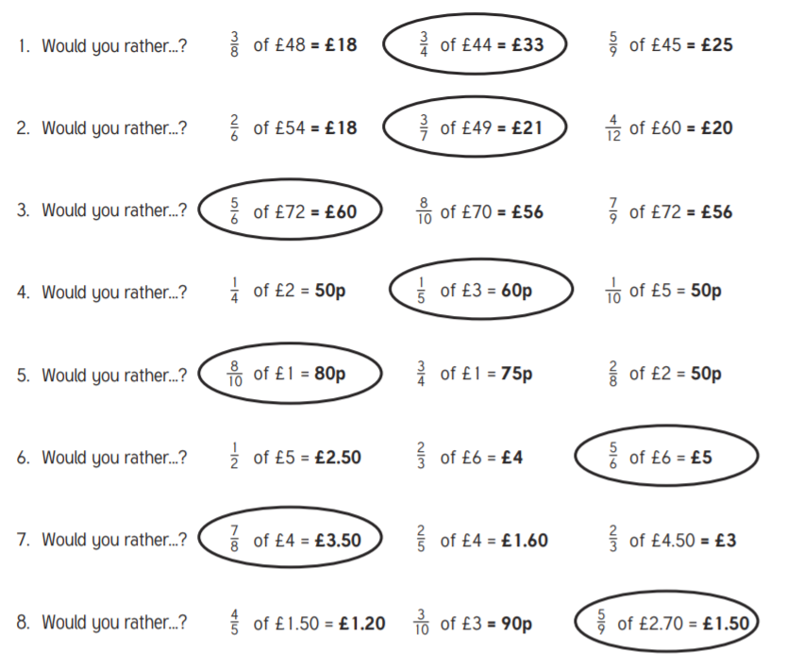

Three star challenge
- Have 10% of £5 or 75% of 80p.
10% of £5 is 50p:
75% of 80p is 60p.
- Have 60% of 2 pizzas or 26% of 5 pizzas.
60% of 2 is 1.2
26% of 5 is 1.3.
- Get bitten by 15% of 120 mosquitoes or by 8% of 250 mosquitoes.
15% of 120 is 18 and 8% of 250 is 20.
- Skip with a rope 54% of 105cm long or with one 88% of 2.75m long.
54% of 105cm is 56.7cm, and 88% of 2.75m is 2.42m = 242cm. I'd prefer using the longer rope.
- Get stuck in a traffic jam lasting 33% of 2 hours or 44% of 1 hr 40 mins. 33% of 120 minutes is 40 minutes
44% of 100 minutes is 44 minutes.

