Robin Hood
Hello my name is layla and today were going be learning about Robin Hood ! 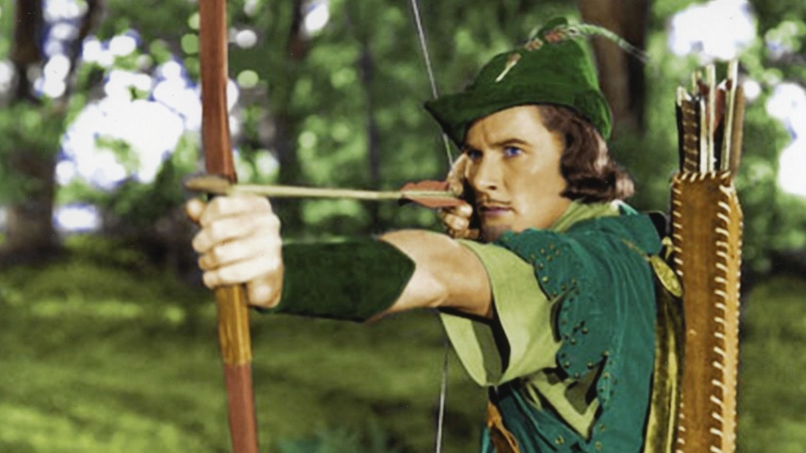
Robin Hood was a real champion at archery. This man never gave up he always fought. Robin stole from the rich and gave to the poor.

Robin Hood was a real person.
Robin lived during the reign of Richard the Lionheart.
Robin Hood was a philanthropist who robbed the rich to give to the poor.
Robin was a dispossessed nobleman, the Earl of Huntington.
Robin married Maid Marian at St Mary's Church in Edwinstowe.

This is Robin’s group of merry men. Robin had a sidekick Little John who got along very well with Robin.


