Read pages from page part two VII
- What simile is used to describe Bess’s face? Her face was like a light.
- What does the word ‘spurred’ mean? (of a rider or their boots) having a spiked device on the heels for urging a horse forward.
- Why do you think there was a bunch of lace at his throat? Stated previously in the poem, the lace was round his chin. As he has fallen off the horse it has fallen to his throat.
- Why does Bess pass away? To warn the Highway man.
- What happens to the Highway man? He is shot down on the highway.
- Find two examples of onomatopoeia. Shrieking, taps, whistles, clatter, clangs
- What did the poet do for the last two stanzas in the poem? Repeated the first two stanzas of the poem.
- Why does the poet use present tense for the final two stanzas? Because the ghosts are still doing it, it is still happening.
- Why do you think red is the only colour mentioned repeatedly throughout the poem? Warning, death, love
- Using information from the text, put a T or an F next to each statement. T = true F = false.
- Bess was the innkeeper’s daughter. T
- Bess was in love with Tim, the Ostler. F
- The Highway man didn’t care when he heard about Bess’s passing. F
- The inn was closed when the Highway man arrived. T

Maths
Problem of the day
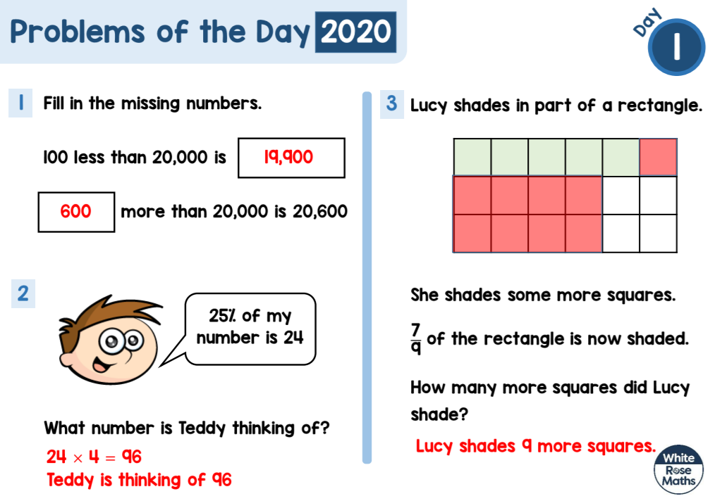

1 star
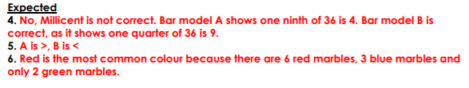
2 star
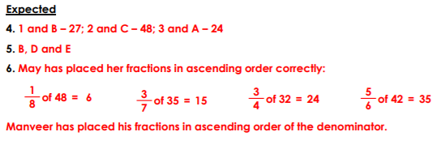

3 star


