Welcome to Google Classroom
As we move into the next phase of remote learning, we are looking to enhance our provision and support by using Google Classroom. This is now going to become the platform where we set tasks, provide support and receive work.
You should have received an email that contains the login details (email address and password) and instructions that will enable you to access the resources. I hope you have had a chance to test your log in and that you can join the class created for your child. Can I please remind you to acknowledge the receipt of this login information and please get in contact with your teacher to discuss alternatives if you are unable to access this program.
This platform allows us the opportunity to hold discussions, provide slides with explanations on how to complete tasks and provide a more simplified way to collect work and tasks with the students. This learning platform is starting to be widely used and meets our online safety guidance as well.
The teachers have been spending some time getting to know the basics of the program and are currently discovering many opportunities to enhance the provision we are providing for you at home.
We are expecting all KS2 children to begin using the system on Monday 20th April (start of summer term). From this date, teachers will be setting daily Maths and English activities, these are expected to be completed (and where appropriate submitted) on that day. As well as this a range of topic based activities will be provided weekly to be completed in an order of their choosing throughout the week.
As teachers and students become more familiar with this system, it will enhance our provision for every child but we will rely upon you to ensure the children are provided with the daily access to the teaching resources and activities as well as opportunities to submit assignments (as called by Google Classroom) and maintain communication with us.
Before the start of next term, the teachers will be in contact (either via email or the class blogs) with more information on how this system works and they will endeavor to answer your questions then.
Thank you for working with us as we move on to the next phase of supporting your child’s learning remotely. If you have any questions or queries, please email your class teacher.
Below is a set of instructions on how to login and join the class.
Yours Sincerely
Mr Munro
UKS2 Phase Leader

Search ‘google classroom login’ or visit google classroom and click here and select google classroom:
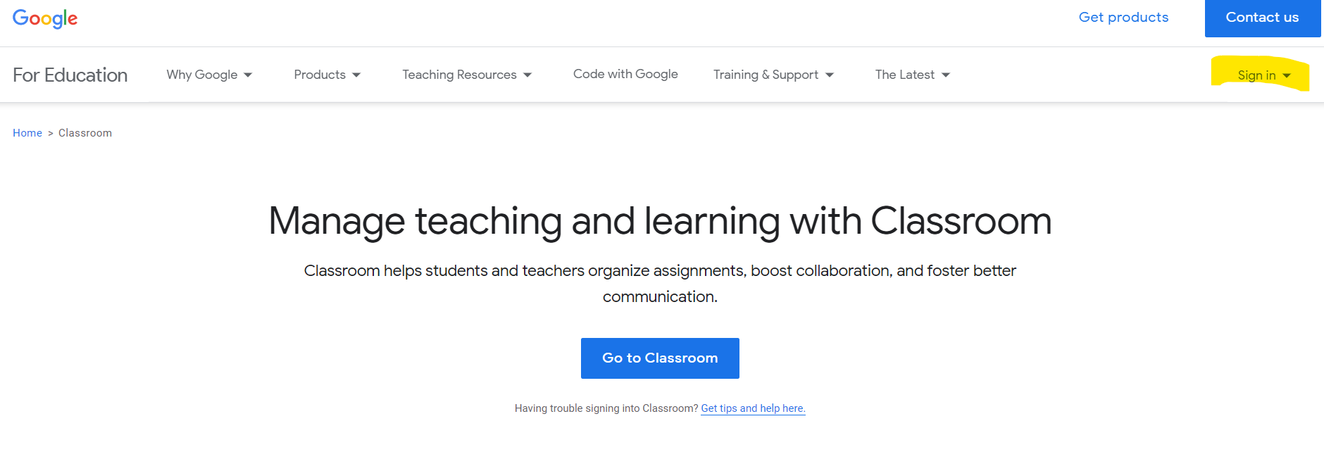
Type in the email provided here and then put in the password:
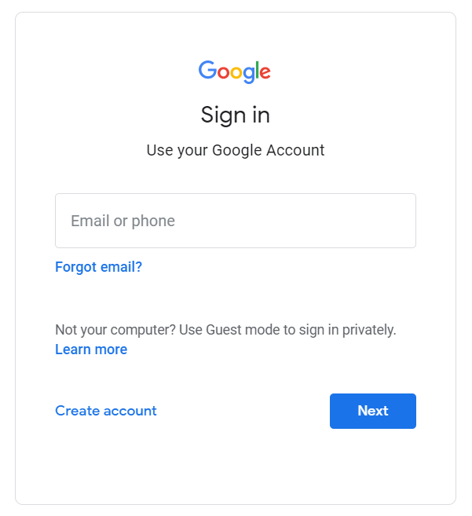
At this point you will need to accept the terms and conditions and then click ‘I am a student’.
You should see an invite from your class teacher at this point to join their class – click join:
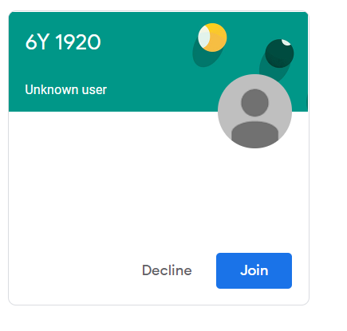
This completes the process of signing up and joining the class.

