Year Three: Autumn Term 1 Home Learning Grid

Over the next half term you should choose 6 activities to complete (1 activity per week). The activities are split across various subjects, each with a different skills focus. You must choose at least one of the activities from each of the different subjects over this half term. You can choose the order in which you complete these activities. However, you must give one piece of work in on the Wednesday of each week. Please keep this sheet in your book bag and get a parent to sign each activity when completed (these will be checked).

IMPORTANT: you must also read with an adult at least 5 times a week which must be noted in the reading record and practise your spellings for a spelling test on Thursdays.
Remember, presentation is important!

English | English 2 | Science | History/Art
Description  We have been learning how to describe people and places.  Write a description of a person from our class.  Remember to describe both what they look like and their personality (only positive descriptions).  During the description don’t mention their name. Write their name at the end, to see if the reader can guess who it is just from your description.  Signature___________________ | Fact File  Create a fact file about ancient Egypt.  Think about the river Nile, the Pyramids, the gods, food and drink, their clothing and the houses. This can be handwritten or presented using an electronic device.  You should ensure information is grouped together and presented in a clear and interesting way.  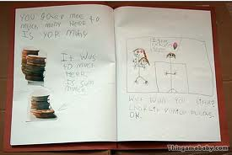  Signature___________________ | Rocks  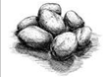  We are studying different types of rocks this half term in our science lessons.  Try to make your own different types of rocks, using chocolate and other ingredients using the instructions provided, or another recipe of your own.  If you bring the finished product into school to share, we can all learn from your efforts.  Signature___________________ | Hieroglyphics  Research the ancient Egyptian hieroglyphic alphabet and then create your own and use it to write your name and a secret message.  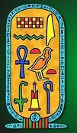  Signature___________________

Maths | History | History/D&T/Art | Family week
Fractions  Write a list of every time you or your family have used fractions within the week. If possible include the faction used e.g. I ate three eighths of a pizza on Tuesday, I drank a third of a bottle of water  .  Signature___________________ | Game  Make a simple game about ancient Egypt e.g. snap, uno, snakes and ladders etc.  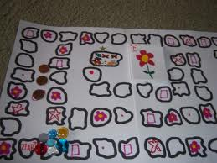  Signature___________________ | Creation of a sarcophagus  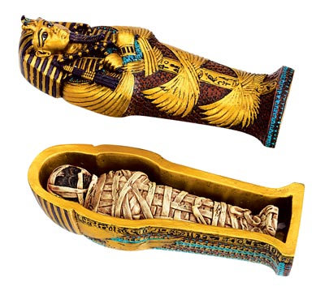  Create your own tomb or coffin (sarcophagus) for a mummy. You can produce this in any way you want.  Remember they are decorated with a picture of the person and show off their wealth.  Signature___________________ | Use this opportunity to explore something as a family.  You might like to record and share what it is you do this week or you might like to choose to spend this week being busy with your family.  It could be:  - A walk in the woods.  - A household chore.  - Eating a meal together.  - Just a busy weekend as a family.  It’s up to you!  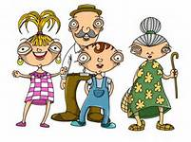  This website could give you some extra ideas:  http://www.theguardian.com/national-trust-wild-time  Signature___________________

