Redwood Drive
Hemel Hempstead
Herts HP3 9ER
Headteacher: Rob Weightman
Telephone: 01442 256294
Email: admin@tudor.herts.sch.uk

Monday 15th May, 2023

Dear Parents and Carers of year 3 & 4,

Lower Key Stage 2 Egyptian Workshop

This past term our topic has been ‘Tomb Raiders’. The children have been learning about ancient Egypt and we are keen to enhance their learning and enthusiasm for the topic with an Egyptian workshop on Friday 30th June. It will take place in school and during school hours by an external company.

The company running the workshop are providing a full days-worth of high quality activities and learning planned for the children, including: an Egyptian quiz; hieroglyph activity; playing Egyptian board games; mummification and burial; ‘hunting on the Nile’ and story-telling. Tudor School is covering the cost of this experience as we aim to provide further exceptional learning experiences for the children from outside professionals.

To truly immerse the children into the day, they will be able to come into school dressed as Ancient Egyptians for the day – there are plenty of ideas and inspiration online for this, but do make sure that they are dressed practically and comfortably.

We very much look forward to sharing this day with the children.

Kind regards

Miss Foy Miss Grundy Miss Gamble Miss Sentence

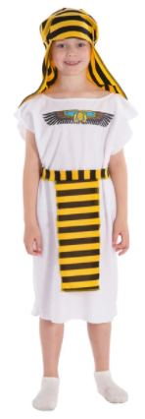
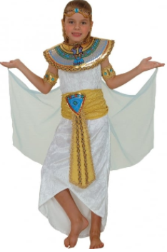
DRESSING FOR OUR EGYPTIAN WORKSHOP

The children can be Egyptologists or Ancient Egyptians - whatever they choose!

EGYPTOLOGISTS - Jeans, shorts, wacky jumpers, “T” shirts, hats.

ANCIENT EGYPTIANS – Ready made Egyptian outfits are readily available on the internet. Cleopatras, Pharaohs, Mummies, slaves...

www.a2z-kids.co.uk www.charliecrow.co.uk

However, it is very easy to make your own outfit. Here are some ideas for making costumes and accessories for our workshop, which can be as simple or adventurous as you like. We would recommend that you show the children the instructions and let them make these costumes at home. The results can be quite amazing!

Instructions
- You will need a length of cheap white material - dust sheets or old bed sheets are perfect.
- Measure from the shoulders to the length required plus a few centimetres (Girls full length, boys to mid-calf or full length.)
- Double this measurement.
- Measure from elbow to elbow. This will be your finished width.
- Fold material in half lengthwise. Cut out a hole just big enough for your head to go through.
Be careful, it’s easy to make this hole too large. Start small!
- Sew up the side seams, A to B, and C to D, being sure to leave a generous armhole.
- Tie round the middle with cord. All Ancient Egyptians can wear bangles and beads.
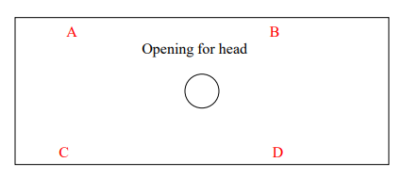

TO MAKE A BOY’S HEADDRESS
- Measure from the middle of the forehead to just below the shoulders.
- Take an oblong of white cloth this length. The width should be enough to tie at the back of the head comfortably.
GIRL’S WIGS
- Wigs can be made from plaited black wool attached to a band of cloth tied around your head.

