The Amazing Pirate Adventure

On the terrifying seas of Cornwall, there was a good pirate ship called Fiery Interceptor who had an evil captain called captain flare. He locked up good people , he attacked fellow pirates and shouted at the crew members.

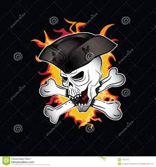

Then, one day they sailed to the vast, amazing Caribbean. That was where they found some shiny, gold treasure.
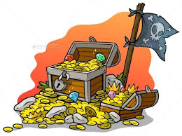Suddenly, a bright , blinding light appeared and it shone right in captain flare’s face . 3 weeks later… the captain started being nice to every one!

Somewhere else…”he is faking it “ said a mysterious voice.
“Definitely” whispered another.
Back in the Caribbean…there was a CRASH and a BANG it was the royal navy! They had come to get captain flare.

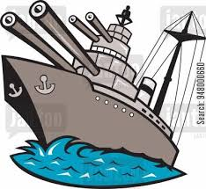

“RUN!!!!!!!!!!!” said a crew member .
Suddenly, a CLICK sound vibrated in the air and a huge wave appeared and a sword fish emerged from it.

